

ME 482 DESIGN PROJECT REPORT

**VEHICULAR REAR-VIEW SYSTEM**

**Prepared By:**

**Team 18 – GYB**

Sean Corro – 20436486  
Richard Tian – 20484119  
Jame Sun – 20464953  
Kelvin Chow - 20466985  
Peter Zhang – 20465875

**Prepared For:**

Professor James Baleshta

Professor Sanjeev Bedi

Professor James Baleshta and Professor Sanjeev Bedi

Department of Mechanical and Mechatronics Engineering

University of Waterloo

200 University Avenue West

Waterloo, ON

N2L 3G1

Dear Professor Baleshta and Professor Bedi,

This report, entitled, “Vehicle Rear-View System” was prepared for the ME 482 as the design project report. The report details the engineering design process in solving the self-defined problem of reducing drag and increasing safety for vehicles.

The report and the design work summarized in the report was done by the members of GYB (Team 18. The main contributions for each group member are as follows:

* Sean Corro – CAD design & Prototyping
* Richard Xu Hua Tian – Mechanics & Project Management
* Kelvin Chow – Electrical Design
* Jame Sun – Analysis and Procurement
* Peter Jing Chi Zhang – Needs Analysis & Software

The team members would like to thank Professor Hyock Ju Kwon, Professor Fue-Sang Lien, Professor Michael Mayer, Professor Sebastian Fischmeister, Professor Sanjeev Bedi, Professor James Baleshta, and Professor Christopher Backhouse for their guidance through the design process. The team did not receive any other additional help. We the undersigned take responsibility for this design.

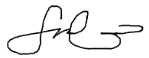Sincerely,

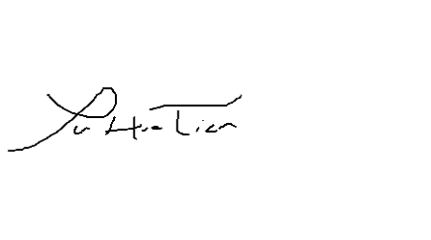Sean Corro

**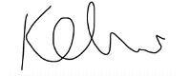**Xu Hua Tian

Kelvin Chow

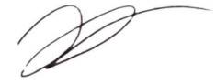

Jame Sun

Peter Zhang

**Executive Summary**

The automotive industry is one of the top contributors of greenhouse gases and the leading cause **1**of external deaths in the US. Vehicles are responsible for 31% **2** of the total CO2 emissions per year in the US alone, while causing over 2 million injuries.**3** Team GYB set out to develop a product that would address these alarming numbers. This was accomplished by looking at areas of a vehicle that would increase driver safety while decreasing overall car emissions. Evaluating many different design challenges, team GYB chose to tackle the advancement of the side mirror (wing mirror) for it’s high impact on safety and vehicle efficiency. Diving into the numbers, the side mirrors cause over 860,000 accidents due to the blind spot or the longer reaction time as the driver is turning their head away from actions in front of their vehicle.**4** It is also responsible for up to 7% of total vehicle drag as research has shown.**5** With the side mirrors having this much impact to the design of a vehicle it was evident that there was a need to improve the existing design and show what technology can help achieve.

Following ME 481, GYB sought to refine and develop a better product through component consolidation of 1 camera vs 2. Using engineering knowledge and automation to create a new design process to find the best design based off drag and mass objectives, as well as refine and validate ideas and designs which were not built.

Regarding the advancement of the side mirror design, there were 3 important areas GYB tackled with this project. The first was the ability to use the product in a wide variety of road conditions ranging from low light conditions to icy weather. The second was increasing driver awareness using object tracking, and finding equipment that would greatly increase the FOV of the driver to eliminate the blindspot. Lastly, GYB developed a new design process to evaluate for the best design in terms of lowest drag and mass while maintaining structural strength. This process used neural networks to increase the efficiency of finding the best design. Combining these aspects into one product allowed team GYB to fully showcase in a prototype build all the benefits the system could provide to drivers.

As a result of the hard work of the team, GYB was able to design a product which decreased side mirror drag by over 99.9% allow for object tracking, be used in multiple low visibility conditions and increasing driver awareness by having video feeds integrated on the dash of the vehicle. Relating to the statistics earlier, GYB reduced the 7% total drag of side mirrors to almost 0%, and by eliminating the blind spot aims to reduce accidents by up to 860,000 per year in the US once implemented.

# Table of Contents

[Table of Contents i](#_Toc479024721)

[List of Figures iii](#_Toc479024722)

[List of Tables iv](#_Toc479024723)

[1 Introduction 1](#_Toc479024724)

[1.1 Background 1](#_Toc479024725)

[2 Design 2](#_Toc479024726)

[2.1 Component Design 2](#_Toc479024727)

[2.1.1 Night Time Driving 2](#_Toc479024728)

[2.1.2 Heater System 2](#_Toc479024729)

[2.1.3 Electrical Design 3](#_Toc479024730)

[2.2 Housing Design 3](#_Toc479024731)

[2.2.1 COMSOL CFD Setup 3](#_Toc479024732)

[2.2.2 COMSOL FEA Setup 4](#_Toc479024733)

[2.2.3 MATLAB Neural Network 4](#_Toc479024734)

[2.3 Software 5](#_Toc479024735)

[2.3.1 Planned Functionality 5](#_Toc479024736)

[2.3.2 Software Foundation 5](#_Toc479024737)

[2.3.3 Software Implementation 6](#_Toc479024738)

[2.4 Design for Safety, Sustainability, and Professional Ethics 7](#_Toc479024739)

[3 Prototyping and Refinements 8](#_Toc479024740)

[3.1 Housing Prototype 8](#_Toc479024741)

[3.1.1 Exterior Housing 8](#_Toc479024742)

[3.1.2 Interior Ribbing 9](#_Toc479024743)

[3.1.3 Lens Mounting 9](#_Toc479024744)

[3.2 Components Integration 10](#_Toc479024745)

[3.3 Software 10](#_Toc479024746)

[3.3.1 Software Foundation 10](#_Toc479024747)

[3.3.2 Software Implementation 11](#_Toc479024748)

[4 Verification and Validation 12](#_Toc479024749)

[4.1 Housing Verification and Validation 12](#_Toc479024750)

[4.1.1 Finite Element Simulation Validation 12](#_Toc479024751)

[4.2 Components Verification and Validation 13](#_Toc479024752)

[4.2.1 Camera vs. Mirror Field of View 13](#_Toc479024753)

[4.2.2 Infrared Emitters 13](#_Toc479024754)

[4.2.3 Heater System 13](#_Toc479024755)

[5 Project Management 15](#_Toc479024756)

[5.1 Project Objectives and Scope 15](#_Toc479024757)

[5.2 Deliverables 15](#_Toc479024758)

[5.3 Schedule 15](#_Toc479024759)

[5.4 Budget 16](#_Toc479024760)

[5.5 Risk Management 16](#_Toc479024761)

[6 Conclusions 17](#_Toc479024762)

[7 References 18](#_Toc479024763)

[Appendix A: Engineering Data A1](#_Toc479024764)

[Appendix B: Engineering Design Specifications B1](#_Toc479024765)

[Appendix C: Verification of Design Data C1](#_Toc479024766)

[Appendix D: Hazard Disclosure Form D1](#_Toc479024767)

[Appendix E: Lessons Learned E1](#_Toc479024768)

[Appendix F: Prototype Images F1](#_Toc479024769)

[Appendix G: Project Management Data G1](#_Toc479024770)

# List of Figures

[Figure 1:Fully parametric exterior housing model 3](#_Toc479024714)

[Figure 2: Top level neural network optimization flow chart 5](#_Toc479024715)

[Figure 3. Raspberry Pi 1 Model B running on Raspbian OS.12 6](#_Toc479024716)

[Figure 4. Software flowchart. 6](#_Toc479024717)

[Figure 5: interior ribbing of iteration #2 9](#_Toc479024718)

[Figure 6: Lens Design considerations 10](#_Toc479024719)

[Figure 7. New prototype flowchart. 11](#_Toc479024720)

Appendix A 1: Electrical schematic with all components A1

Appendix A 2: Iteration #1 housing CAD A1

Appendix A 3: Iteration #1 Lens CAD A2

Appendix A 4: Iteration #2 Housing CAD A2

Appendix A 5: Iteration #2 Lens Cover CAD A3

Appendix C 1: Mesh Independence Study FEA Comsol C1

Appendix C 2: Detailed Neural Network Flowchart C1

Appendix C 3: IR Intensity data graph C2

Appendix C 4: Dual Bandpass filter specification graph C2

Appendix C 5: Effects of dual bandpass filter from unrestricted spectrum C3

Appendix C 6: Video feed comparison; filter(top), no filter(bottom) C3

Appendix C 7: Night time IR demo, highway speeds C4

Appendix C 8: Field of View test, comparing side mirror to video feed C5

Appendix C 9: Defrost system test before and after C5

Appendix C 10: Max Lens Temperature (3 minutes of heating) C6

Appendix C 11: Max temperature of Transparent lens C6

Appendix F 1: 3 axis load case for FEA F1

Appendix F 2: Camera constraining exterior housing width and lens height F1

Appendix F 3: PCB layout showing contact pads for components F2

Appendix F 4: PCB overlay on camera showing packaging F2

Appendix F 5: final PCB and camera prototypes; iteration #1 (left), iteration #2 (right) F2

Appendix F 6: iteration #1 prototype 3d printed housing F3

Appendix F 7: Iteration #1 side profile F3

Appendix F 8: iteration #2 isometric profile F3

Appendix F 9: Iteration #2 side profile F4

Appendix F 10: Iteration #2 cover front view F4

Appendix F 11: Iteration #1 (top right) vs Iteration #2 (bottom left) size comparison F4

Appendix G 1: Project Budget G1

Appendix G 2: Project Man-Hour Budget G1

Appendix G 3: Project Deliverables G1

Appendix G 4: Project Schedule G2

# List of Tables

[Table 1: Housing Parameters 3](#_Toc479024710)

[Table 2: Housing Parameters set for Iteration #1 8](#_Toc479024711)

[Table 3: Housing Parameters for Iteration 1 vs 2 8](#_Toc479024712)

[Table 4: Lens Design Considerations 9](#_Toc479024713)

# Introduction

## Background

Over the last few decades, the evolution of the automobile has been resoundingly evident. However, one part of the car that has remained constant is the side mirror. The stagnated, prehistoric design of the side mirror is the motivation behind this project.

The side mirror, with its limited viewing angle of 21° creates a dangerous blind spot on the side of the vehicle.**6** In the United States, 840,000 accidents occur annually because of vehicular blind spots [https://www.fortheinjured.com/blog/blind-spot-accident/]. Because of the blind spot, there is a need for the driver to rotate their head 90° on both sides to check their blind spot. The side mirror also is horribly designed for aerodynamics. Although it is relatively compact in size, the side mirror is responsible for 2-7% of vehicular drag.**5** Improving the drag force would reduce the CO2 emission as well as improving fuel economy of vehicles. As such, the need exists to create a safer, more aerodynamic rear view system that would supplant the side mirror.

In ME 481, team GYB designed and prototyped a compact camera system enclosed in an aerodynamic housing as a replacement to traditional side mirrors. The camera system prototype was intended to address the side blind spots and high aerodynamic drag associated with traditional side mirrors. Due to the inherent large field of view of the camera, the prototype camera system drastically reduced side blind spots compared to a side mirror.**7**

Through several intuitive design and analysis iterations, GYB devised a housing design that resulted in a drag reduction of over 90% compared to a standard side mirror. Furthermore, it was shown that the housing satisfied the external loading requirements as outlined by regulations. **7**

Following the results of ME 481, team GYB pursued a more analytical approach to reformulate the design of the exterior housing in ME 482. The main driving force behind this was to explore and optimize for the wide design space of the project, and compete in the ANSYS Design analytics competition. **7**

During ME 481, the team based the housing shape on engineering intuition to minimize mass and drag. Although a 98% drag reduction was achieved compared to a side mirror, the design process was slightly ignorant to figuring out a proper method to find the best design. This is where in ME 482 a new design process was setup to find the lowest drag, lowest mass housing based on our design space. **7**

In addition to the design process change, there were items that GYB had to let go in order to deliver a working product at symposium. The team narrowed down on several key deliverables to focus on and forgone the remaining optional objectives. Safety was our main driving factor. To allow for a safer wing mirror system 4 aspects needed to be validated for and tested before symposium. The 4 items were: Field of view, Image quality (different outdoor conditions), night time IR, and object tracking. Allowing these to be the main goals for ME 482 would produce an end product that would address many of the safety concerns. It would also be a great display of how the system would work in a production capacity. In addition, drag and mass were important due to vehicle efficiency and greenhouse gas emissions. Emphasis on validation of the CFD and FEA were required to output significant results.

# Design

## Component Design

The component design focuses on improving vehicular safety and functionality. The two targeted objectives to improve safety from a component standpoint were to increase the field of view of the side mirror with a camera and improve driving conditions at night. Through an intensive design selection process in ME 481, the camera was selected as the Raspberry Pi NOIR camera with a field of view of 62°.**7**

### Night Time Driving

A focus for this project was to improve visibility for low-light conditions. This was accomplished through the assistance of infrared technology. Near infrared radiation is commonly used to enhance image quality in night vision systems.**8** By using infrared emitters, it would allow for more light to enter the camera sensor while being invisible to other drivers.

The infrared emitters that were chosen were the SFH 4715AS manufacturing by OSROM.**9** This emitter was chosen because of its small geometry (3.85x3.85x2.3mm), the high viewing angle (90°), and the high radiant intensity (780 mW/sr). These parameters made it the optimal infrared emitter for this application.

Regular cameras have a filter to block off transmission of non-visible light such as ultraviolet and infrared radiation. The sun emits electromagnetic radiation at all wavelengths. Figures in Appendix C show the effect infrared radiation has on an image. It distorts the image with a red tint.

Since the design utilizes infrared emitters that emit at 850 nm, using a filter to cut off transmission of all non-visible light would not be a suitable choice as it would block out the infrared emitters. The solution was to choose a dual bandpass filter which would allow for transmission of visible light as well as a narrow band with a peak transmission at 850 nm to match the infrared emitters chosen. The result of using this dual bandpass filter was to block off the majority of non-visible light to create a non-distorted image. In addition, the filter would allow for transmission of the infrared emitters to allow for operation during low-light conditions.

### Heater System

A major concern for the system was that the lens would freeze over and cause the driver to be unable to see through the camera. Like current side mirrors, the solution to this problem was to implement a heater defrost system. The required heat flux was estimated to be 430 W/m2. Therefore, the heat requirement on the final lens housing must be 0.05W.**10**

The most resistive nichrome wire was selected to reduce risk of overheating the lens by outputting an excessive amount of heat. Since the selection was limited due to wire availability, 36 AWG nichrome 80 with a resistance of 26 Ω/ft was selected. As a result, a PWM duty must be employed to ensure no overheating would occur. Using the selected wire, a 7% duty must be applied using a 1.5V power supply. To ensure the safety of the final design, a heat study was run on the lens with the worst-case scenario of 100% duty to ensure that the lens does not overheat. A maximum temperature of 36°C was recorded in driving ambient conditions of 0°C. The study is included in the appendix A.

### Electrical Design

A Raspberry Pi microcontroller was used to control the operation of the camera, infrared emitter, and the heating system. An ambient light sensor would be used to detect the lighting environment to toggle the IR emitter. Similarly, a temperature sensor would measure the temperature of the lens to control the heating system. An electrical schematic diagram is shown in Appendix A.

## Housing Design

Having a new focus for the design of the exterior housing, the original design was reformatted to allow for easy exterior modification. This was done by fully parameterizing the CAD. 6 parameters were chosen to the encompass the exterior shape. 3 parameters were chosen to represent the inner features of the housing. The parameters are listed below:

Table : Housing Parameters

|  |  |  |
| --- | --- | --- |
| Width | 35.0 mm | Constrained based off electrical component requirements |
| Depth | 120.0 mm | Optimized based off neural network prediction |
| Lens Height | 37.0 mm | Constrained based off electrical component requirements |
| Spline X | 66.6 mm | Optimized based off neural network prediction |
| Spline Y | 31.0 mm | Optimized based off neural network prediction |
| Lens Fillet | 6.0 mm | Optimized based off neural network prediction |
| Thickness | 2.5 mm | Optimized based off neural network prediction |
| RibX | 12.0 mm | Optimized based off neural network prediction |
| RibY | 20.4 mm | Optimized based off neural network prediction |

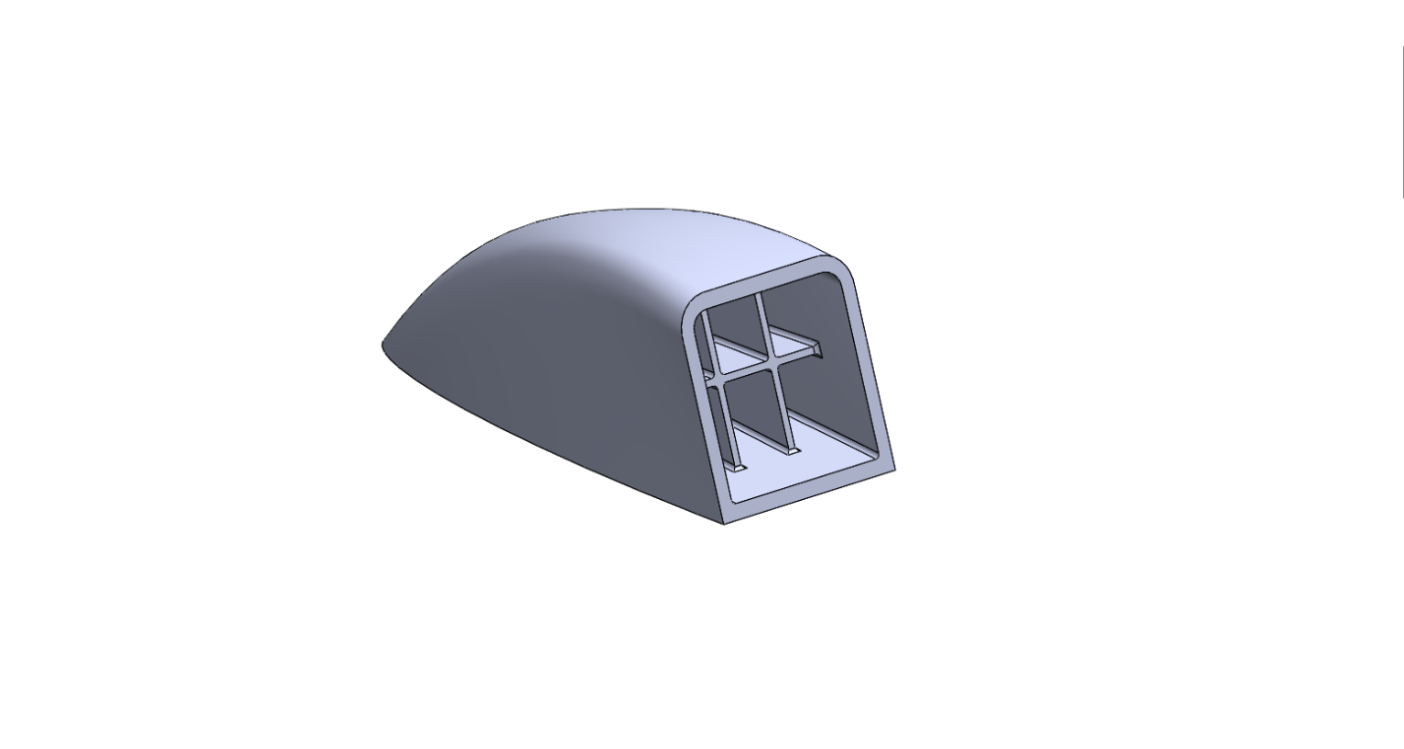

Figure :Fully parametric exterior housing model

The exterior parameters were chosen based off defining enough variables to fully parameterize the model. Of note, Spline X and Spline Y was originally combined into a loft surface variable, but due to errors with Solidworks updating using global variables, it was altered into a spline surface loft needing both the X and Y coordinate. The angle of the lens cover was unchanged from ME 481 at 15 degrees to provide the widest FOV possible based on camera specifications outlined in the components section of the report.

### COMSOL CFD Setup

To setup the CFD simulation, the SOLIDWORKS model was ‘livelinked’ into COMSOL to allow modification of SOLIDWORKS parameters within COMSOL. As per design specifications, the housing was modelled to be simulated in 30 m/s turbulent flow to demonstrate the worst case drag effects on the housing. Normalized air at 25 $°C$ was used as the flow medium. K- $ϵ$ model was utilized to quantify the effects of recirculating flow along the housing profile.

Mesh settings were used as follows: Maximum element size of 5.93 mm, minimum element size of 1.12 mm, maximum element growth rate of 1.13, curvature factor of 0.5 and resolution of narrow regions of 0.8. Tetrahedral shape was used as the domain mesh shape. XYZ direction scales were left as 1. The final procedure was the implementation of an inflation layer on the base surface of the model. This inflation layer is responsible to quantify the wall shear effects of the flow along the surface. The parameters of this layer are as follows: 8 boundary layers, boundary layer stretching factor of 1.2 with an automatic first layer generation and a thickness factor adjustment of 1.

### COMSOL FEA Setup

To setup the FEA simulation, the SOLIDWORKS model was ‘livelinked’ into COMSOL to allow modification of SOLIDWORKS parameters within COMSOL. As per design specifications, the housing was to withstand a 140N load. 3 areas were chosen based on the 3-fundamental axis and are shown on appendix 1. Applied area for the 140 N loads were affixed to be 1cm in diameter to simulate the area of a thumb/large pebble.

The entire model was simulated to perform as a linear elastic model. The material chosen to be simulated was ABS GF30% for its high impact resistance. In addition, a fixed constraint on the bottom surface of the model was chosen to simulate be affixed to the body panels of a vehicle.

Mesh sizing were chosen to be a maximum of 11.1 mm, minimum of 2 mm with a maximum growth rate of 1.5, curvature factor of 0.6 and resolution of narrow regions of 0.5. The mesh settings were chosen as a result of performing a mesh independence study on the load cases and their total strain energy on the exterior body. The chart can be found in appendix 2. By choosing the point where total strain energy stabilizes, the computational resources necessary to complete the simulation is decreased while maintaining significant results.

### MATLAB Neural Network

To further minimize the aerodynamic drag and weight of the housing and maximize its structural strength, the exterior and interior housing parameters are further optimized using the neural network regression technique in MATLAB.

As part of the MATLAB Machine Learning Toolkit, the MATLAB neural network function encompasses a variety of functions such as deep learning and regression. For this application, the neural network regression fitting function is used in conjunction with COMSOL Multiphysics to create an automated iterative learning feedback loop. With each iteration, the neural network performs regression fitting on an existing pool of simulation data and makes a prediction for the optimized solution, which includes a set of inputs and a predicted output. COMSOL then performs a CFD or structural simulation according to the set of inputs and computes a validated simulation output, which is transferred back to the neural network in MATLAB. The neural network compares its output prediction against the simulation output from COMSOL and adapts its neuron weightings to prepare for the next iteration (Fig. 2).

Existing literature on neural network assisted drag optimization was heavily referenced to construct the neural network setup.**11** During exterior housing optimization, the neural network was able to design a housing contour with a drag value 3 standard deviations below the mean drag after only 100 learning iterations. Furthermore, the neural networkw was able to independently make predictions that were 99.99% accurate in a small, well-studied area of interest in the design space. The interior housing parameters, such as wall thickness and housing rib locations, were optimized using the same workflow. A detailed flow chart can be found in Appendix C.

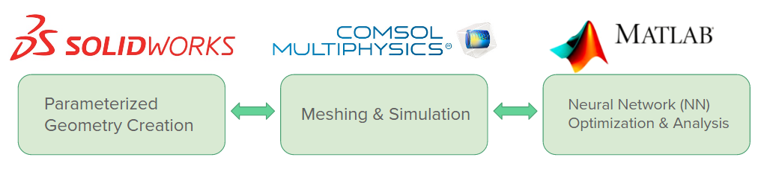

Figure : Top level neural network optimization flow chart

## Software

### Planned Functionality

Ideally, two main functions can be implemented: dashcams’ video saving feature, and blind-spot object detection.

#### Dashcam Feature

Nowadays, many drivers are opting to equip their vehicles with dashcams, either front-facing, back-facing or both. The primary function of a dashcam is to continuously record video of the surroundings of the vehicle to be used as evidence when driving accidents occur. Since the envisioned design uses camera sensors on both sides of the vehicle, a similar feature can be implemented as a back-facing dashcam alternative. A simple program can be written to save the past x-seconds of video to the hard drive of the Raspberry Pi.

#### Blind-spot Object Detection

A much more difficult feature to implement is object detection. Even though the design already decreases the driver’s blind-spot by a significant amount, an additional layer of safety can be provided if the design can somehow provide an indicator to the driver when an obstruction/object is currently in the blind-spot. Using the video feed from the camera sensors, a program can be written to identify cars in the blind-spot and alert the driver by displaying it on the displays, either as a box around the object, or with a separate LED.

### Software Foundation

The following specifications are relevant to the software design aspect of the project. Both the hardware and software involved are discussed.

#### Raspberry Pi Microcontroller

The Raspberry Pi (1 model B) microcontroller comes with the Raspbian operating system pre-installed. It is officially provided by Raspberry Pi Foundation as the primary operating system for all Raspberry Pi models. As such, unlike other Unix-based operating systems, Raspbian is incredibly optimized for the low-performance central processing units (CPU) used in all Raspberry Pi models. This makes it possible to leverage the full amount of the limited power of the Raspberry Pi’s CPU towards the CPU intensive functions of real-time image processing.**12**

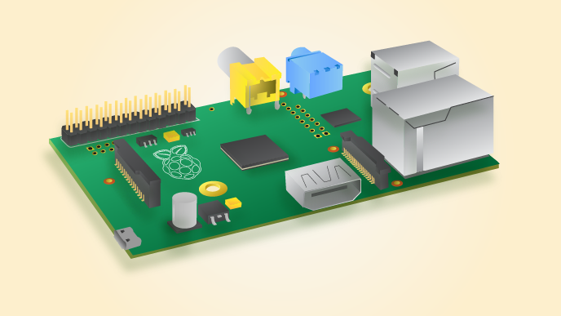

Figure . Raspberry Pi 1 Model B running on Raspbian OS.12

#### Python

Raspbian is capable of running Python out-of-the-box, which makes it the ideal language in which to begin programming since the compiling of an entire programming language such as C++ would likely be very time consuming. Many team members also have experience with programming in Python, and are very comfortable with it; therefore, it is temporarily selected as the primary programming language that will be used to implement the planned functionality of the design.

#### OpenCV Library

OpenCV (Open Source Computer Vision) is a programming library of functions that is generally used for tackling problems in real-time image processing. It is by far the most important resource on the software side, as it has many functions specifically tailored towards features that are within the project’s software functionality scope. It is written in C++, but there are bindings for it in Python and several other programming languages. This essentially cemented Python as the primary programming language that will be used for the project. Documentation for OpenCV can be found on the OpenCV library website, along with some simple tutorials.

### Software Implementation

The implementation of the features can be better understood by breaking the processes for each feature down into a sequence of operations or a flowchart. The flowchart is shown below in Figure 4.

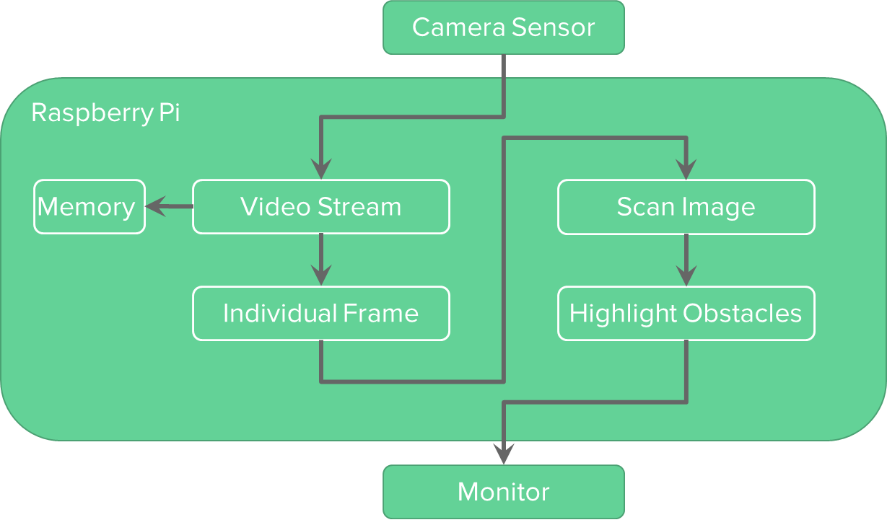

Figure . Software flowchart.

Essentially, the video feed is taken from the camera sensor, and stored in a time-restricted (deletes anything older than x-seconds) memory buffer. In practice, when specified by the driver (after an accident), the memory is written to the permanent hard-drive. At the same time, the individual frame from the sensor is isolated, and scanned for objects. The scanning process is discussed in more detail below. If an object is found, it is highlighted with a large neon box and sent to be shown on the display.

Regarding the scanning of images, two different methods are used to identify objects. The simpler method is the colour-tracking method, in which the image is searched for large “blob” like objects of a consistent colour scheme. If the shape and colour matches the shape and colour specified by the user, tracking succeeds.**13** The second method is more difficult to understand. It utilizes haar-cascades, which are files trained to recognize certain features of a certain class of objects. For example, the shape of a car can be broken down into several key points (features), all connected by either straight lines or contours. The points and connecting lines are represented as numbers in the haar-cascade file. This file can then be used to identify the features of the car in all other images. If the cascade finds an object in the image, the tracking succeeds.**14** Both methods of tracking are used in conjunction with each other to ensure accuracy and by extension, safety.

## Design for Safety, Sustainability, and Professional Ethics

As safety was one of the larger issues team GYB wanted to address, it has been integrated within the system to provide as much safety in terms of driver awareness and regulation validation. FMVSS 111 has been the standard to which the housing has been tested against for all our mounting and structural specifications. By ensuring we meet and exceed the regulatory standards, we can design with safety in mind first. Above and beyond just regulatory constraints, GYB tasked ourselves with creating the best possible driver awareness package to decrease reaction time and ensure a safer drive. This was achieved in a few ways. The first was the use of a wide FOV camera. By increasing the field of view we allow more information to be shown to the driver who can make an informed decision. On top of this, during night time driving, where visibility might be poor GYB has been able to show a working prototype with the use of IR emitters to illuminate up to 10m away from the car giving more road detail again to properly inform the driver of any issues. Another feature added to address safety was the use of object tracking. There are instances where objects are not easily detectable and by using computer tracking we can help guide focal areas around the car to potential dangers. The last feature was the implementation of the LCD monitors on the dash board to the left and right of the steering wheel. By having the displays right next to the wheel we reduce driver reaction time as compared to a normal driver looking to the blind spot and trying to react to a situation in front of their car. With this implementation, the driver will always have their head facing the direction where the car is going.

In terms of sustainability, we also designed the product based on the conditions it would see in real life. ABS GF 30% chosen for impact resistance to rocks/debris kicked up by the car. Gloss painted and clear coated to reduce weathering effects on the ABS material, as well as implementing a heater system for conditions where ice buildup or snow starts to affect visual performance. Aspects such as draft angles along the lens to drain any water are all addressed in this design to be sustainable to reach or exceed the end of life of a typical vehicle while being much more aerodynamic, and smaller in mass amounting to an overall decrease in greenhouse gas emissions.

Other areas of professional ethics are through the transparency of the report. The report does not use any made up numbers and has been prepared with the user in mind. All numbers achieved have been fully validated and have been double checked for consistency.

# Prototyping and Refinements

## Housing Prototype

### Exterior Housing

Prototype #1 was determined based on the neural network prediction. The neural network predicted housing parameters as follows:

Table : Housing Parameters set for Iteration #1

|  |  |  |
| --- | --- | --- |
| Width | 35.0 mm | Constrained based off electrical component requirements |
| Depth | 120.0 mm | Optimized based off neural network prediction |
| Lens Height | 37.0 mm | Constrained based off electrical component requirements |
| Spline X | 66.6 mm | Optimized based off neural network prediction |
| Spline Y | 31.0 mm | Optimized based off neural network prediction |
| Lens Fillet | 6.0 mm | Optimized based off neural network prediction |
| Thickness | 2.5 mm | Optimized based off neural network prediction |
| RibX | 12.0 mm | Optimized based off neural network prediction |
| RibY | 20.4 mm | Optimized based off neural network prediction |

The results of these parameters amounted to 0.107 Newtons as compared to 50N for a conventional side mirror (99.7% reduction in drag). Maximum stress within the structure was found to be 98 MPa without the structural rigidity of the lens assembly making the 3 load cases lower than the yield strength of the ABS GF 30% material.

To prepare a physical prototype for validation and symposium, Additive manufacturing was utilized. This was chosen based on the cost-effective nature of building for low volumes, and due to the housing curvature profile. Material chosen was black ABS plastic and oriented with the depth along the z-axis of the print bed to maintain wall quality. Overall print time for both the lens and the housing took just shy of 6 hours.

The main constraint of the first iteration was the camera board being used. As shown in appendix 3, the PCB is affixed with the camera module causing the housing to accommodate for more than just the camera housing. This was the initiation of finding other camera modules which is outlined in the components section in further detail. The camera module that we found was a raspberry pi spy camera which detached the PCB from the camera module and linked the two together by a proprietary cable. This would allow for a much smaller housing to be produced. The workflow with the new size constraints would still work by utilizing the adapt function in the Matlab neural network module outlined in section 2.2.3.

The second prototype used a smaller ‘spy camera’, the dimensions of the exterior housing were changed to:

Table : Housing Parameters for Iteration 1 vs 2

|  |  |  |
| --- | --- | --- |
|  | Iteration #1 | Iteration #2 (spy camera) |
| Width | 35.0 mm | 25.0 mm |
| Depth | 120.0 mm | 70.0 mm |
| Lens Height | 37.0 mm | 13.0 mm |
| Spline X | 66.6 mm | 65.0 mm |
| Spline Y | 31.0 mm | 7.0 mm |
| Lens Fillet | 6.0 mm | 3.5 mm |
| Thickness | 2.5 mm | 2.0 mm |
| RibX | 12.0 mm | 9.0 mm |
| RibY | 20.4 mm | 5.0 mm |

The changes amounted to a total drag force of 0.017 Newtons, an almost 85% reduction in drag as compared to iteration #1 and over a 99.9% reduction in drag as compared to a conventional side mirror. The housing was tested to comply with a maximum stress of 99 MPa, under the yield strength of the ABS GF 30% material chosen to be used in a full production capacity.

The same process was used to create a physical prototype as compared to iteration #1. Build time took just over 1 hour due to the significant reduction in material size.

### Interior Ribbing

To achieve the required structural strength of the FEA setup while maintaining minimal mass, ribs were used. The ribbing would allow a direct stress flow within the ribs to lower maximum stress seen while achieving lower overall mass. The ribs were chosen to be half the exterior wall thickness based off injection molded guidelines.**15**

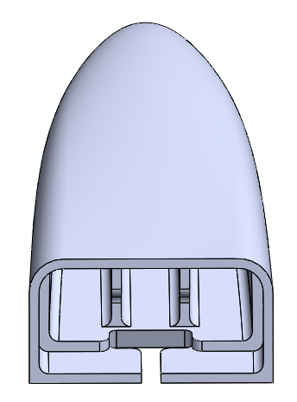

Figure : interior ribbing of iteration #2

### Lens Mounting

To complete the housing package, the lens cover needed to be designed with several factors in mind. The table of factors are listed below:

Table : Lens Design Considerations

|  |  |  |
| --- | --- | --- |
| Issue | Solution | Location |
| PCB mounting | Mounting screws 2mm diameter by 5mm depth with pre-molded holes | 1 |
| Locating | Locating pins to accurately place and hold the PCB before screwing | 2 |
| Lens Installation | Shallow ledge to insert and hold the lens, where adhesive will be used to seal the components | 3 |
| Outdoor flare | Lens cap to block out light causing lens flare | 4 |
| Fit | Tolerance fit combined with adhesive to achieve water-tight seal. | 5 |

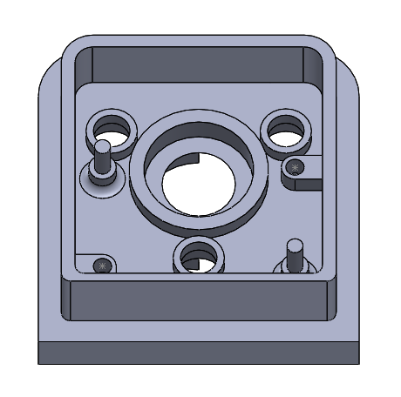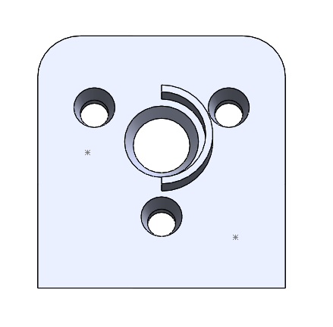

1

2

3

4

5

Figure : Lens Design considerations

## Components Integration

The geometric constraint of the housing prototype was determined by the size of the electrical components. The Raspberry Pi camera was attached to a PCB that was 25 x 25 mm. To not add additional geometric constraints, the rest of the essential electrical components (emitters, heating connection, and sensors) would be integrated on another PCB with the same dimensions as the camera PCB. This second PCB, with a square hole cut out for the camera, would be overlaid over the camera PCB. See Appendix F for the new PCB that corresponded to the first housing prototype.

After testing the IR emitters, an issue arose that caused a shift in focus of the electrical integration. When a current of 1000 mA ran through the emitters, thermal management was a significant problem. The sensors were abandoned and the focus of the new PCB was to integrate the emitters only. The emitters were spread out through the PCB, and the current was reduced by half to improve the heat dissipation of the emitters. Also, to improve heat dissipation, the copper area was increased by roughly ten times.

Since the first PCB prototype only focused on integrating the IR emitters, the second prototype of the PCB for the second housing contained only the emitters also. The second PCB had two emitters, one on each side of the camera. Appendix F shows the layout of the second PCB.

## Software

### Software Foundation

The following aspects of the initial software foundation are revised and the reasons are discussed in detail below.

#### Raspberry Pi Microcontroller

The original Raspberry Pi purchased is the Raspberry Pi 1 Model B, which is one of the oldest models available, and accordingly, the processing power is extremely low. Hence, the newest model, the Raspberry Pi 3, was purchased to be used instead.

#### Python & OpenCV

No changes are required to the programming language and main library depositories since they are both still relevant and ideal to the design.

### Software Implementation

Even with the upgrade to the Raspberry Pi 3, the program has trouble running past a specific frame-rate due to the complexity of functions called from the program. In order to increase the frame-rate, the concept of multithreading is utilized. The adjusted flowchart is shown below in Figure 7. Note that the dashcam function is unchanged, but the memory module is not shown in the flowchart for visual purposes.

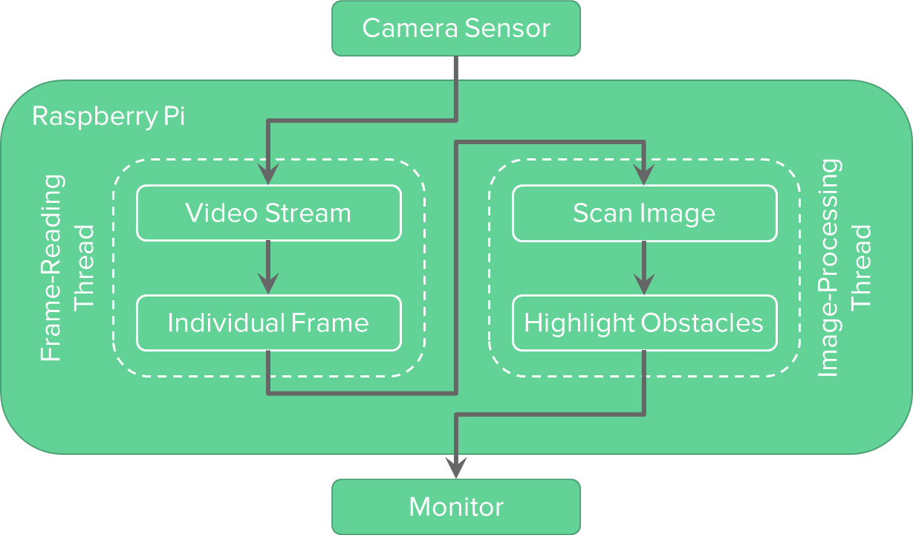

Figure . New prototype flowchart.

Here, the process is broken down into two: frame-reading and image-processing. Essentially, while the CPU is still working on identifying and highlighting objects in the image, a separate “CPU” (thread) is used to read the next image from the camera sensor. This drastically increases the output frame-rate of the video display since the two threads are working in tandem and the CPU is basically multitasking both processes.

The new code for the new program is available upon request.

# Verification and Validation

## Housing Verification and Validation

The main purpose of the housing prototype was to look at packaging and integration. Due to build constraints, not being able to have a through hole on the fender of the test vehicle, the printed build was made with minor modifications. The modifications allowed the cables inside the housing to exit and be routed along the body panel but sacrificed our ability to test for water ingress. Once the 3d printed components were done it was found that due to the material shrinkage the model would need to be reprinted with conservative tolerances amounting to 10-20% increase in feature size depending on the area. It was also noted that the locating pins on the 1st iteration prototype needed to be reinforced with a larger base since there were instances where the locating pin would break due to the small radii and the height of the pin. The pin height was reduced from 7mm to 5mm and the base radii was expanded to 2.5mm to create a stronger feature. Alterations such as sanding and filing the contact surfaces needed to occur as 3D printed surfaces are not flat and have profiles with peaks and valleys associated to each layer height pass of the printed material. This was another reason for not testing for water ingress in a physical capacity. With the 3D printing and sanding/filing it would not reflect the real production product.

Of note, because of the anisotropic behavior of the 3D printing platform, and the material not being glass filled reinforced, the load case testing was solely based on simulations within COMSOL. To aid in recreation of a real-life scenario, literature from COMSOL’s blog was referenced.**16** As outlined in the housing prototype section, the first iteration was rated for a maximum stress of 98 MPa, under the yield stress of the ABS GF 30% material chosen for a mass production capacity.

### Finite Element Simulation Validation

In the housing design and optimization processes, commercial finite element analysis (FEA) software were used extensively to perform structural and computational fluid dynamic (CFD) calculations.

To perform CFD analysis on the exterior housing shape in order to calculate housing drag, ANSYS CFX was initially used in ME 481. In spring 2016, three group members completed ME 566 – Computational Fluid Dynamic for Engineering taught by Professor Fue-Sang Lien, the team’s faculty advisor in ME 481. The initial ANSYS CFX simulation setups were based off of ME 566 course material as well as private instructions from Professor Lien. The simulations results that were obtained also approved by Professor Lien at the end of ME 481.

In ME 482, the CFD simulation was migrated over to COMSOL Multiphysics, a popular and well-validated software package primarily used in academia. The decision to use COMSOL was made due to its capability to couple with MATLAB and SolidWorks, as well as due to one team member’s extensive experience in using COMSOL. The simulation settings in COMSOL were mostly identical to the ANSYS CFX settings. Furthermore, the mesh and boundary condition settings were adjusted according to literature on an accurate vehicular drag simulation using Ahmed Body published by COMSOL.**17**

The structural finite element simulations used in ME 481 were first performed using ABAQUS as the final course project in ME 559 – Finite Element Methods taught by Professor Naveen Chandrashekar, in which three team members were enrolled. The simulation approach, method, and settings were based off of course material and team members’ related work experience, and received overwhelmingly positive feedback from the ME 559 teaching team. The simulation results obtained from the ME 559 course project were used to validate the prototype housing strength.

In ME 482, the structural simulation was migrated to COMSOL Multiphysics for the same reasons as outlined above. All physics and mesh settings were left intact, or based heavily on ABAQUS settings. A mesh independent study was also produced to validate the COMSOL mesh settings.

## Components Verification and Validation

### Camera vs. Mirror Field of View

To ensure that we achieve the greatest field of view, the camera orientation and the resolution settings used were the most important factors. With a 4:3 aspect ratio on the sensor we set out the installation to have the 4 side along the horizontal while the 3 would be the vertical. This would allow us to achieve the largest FOV as outlined in the camera specifications. In addition to this, due to the display size being 16:9 we had to choose an appropriate resolution which would only crop the vertical picture but not the horizontal picture. To accommodate for higher frame rate while maintaining clear picture, 720p resolution was chosen.

To test the FOV vs conventional side mirrors, there were 2 physical tests done. One was physically looking at a stationary object and moving it until it left the view of the side mirror and left the view of the camera. We were able to confirm that the display with the proper orientation and 720p resolution achieved the 62-degree field of view.**18** In addition to this test, was a physical driving demo showing the field of view of the two systems in a driving situation. This was outlined in our FDR presentation with a video created and a bird’s eye view showing where you can see visual objects and the difference in driver reaction time.

### Infrared Emitters

During the prototyping stage, it was found out that the infrared LEDs at the rated 1000 mA caused the solder between the LED and PCB to melt. After redesigning the PCB to run 500 mA through the LED, the emitters were left running for ten to fifteen minutes. The current is directly proportional to the heat dissipated of the LED solder pad based on Joule’s first law.**19** Theoretically, if the emitters were left on, he temperature profile would be an initial increase, and then settle to a steady state temperature. The current profile would follow the same profile. Thus, the emitters were left running until it reached the steady state current, meaning the PCB reached a thermal equilibrium. Once this occurred, the PCB underwent a technical stress test to ensure the solder connection was secure.

To improve night time driving, 3 IR LEDs were utilized operating at half the rated current. The results of this setup was enough to visibly see an object 10 metres away with no other external light. 10 metres is approximately 2 car lengths behind. Multiple night time driving test videos were taken to verify the advantages of using the LEDs over the side mirror in low-light conditions. With the LEDs, the camera was able to pick up the lane markers significantly more than the human eye through the side mirror. It was also able to clearly see reflectors on the side of the road. In absolute darkness, the camera was able to see its immediate surroundings compared to complete blackness from the human eye. See Appendix C for the results of night time testing.

### Heater System

The defrost heater was installed on the final housing lens and was subsequently frozen to test the functionality of the heater. The lens was frozen with roughly 3mm thick ice. The heater was turned on with 100% duty and left to run until the view was fully clear. The entire process was recorded to take 1 minute and 30 seconds. The comparison pictures of the defrost system is included in Appendix C.

# Project Management

## Project Objectives and Scope

The objective of ME 482 is to create a fully functional working prototype and to validate the system through various tests and analyses as outlined in ME 481. This project creates an optimally aerodynamic system with auxiliary functions to increase driver safety. The auxiliary functions will be outlined by the scope of this project. The scope of this project is mainly limited due to the time constraints of this course. As a result, the scope of the project has been minimized to reduce the risk of not completing the project.

The scope of the project was carefully considered and sized to include the following:

1. Housing
2. Camera system
   1. Night vision
   2. Object tracking
3. Defrost system

## Deliverables

In ME 481, deliverables were broken into two sections: course deliverables and project deliverables. In M482, the deliverables were split in a similar fashion. The project deliverables are milestones and deliverables required by the ME 482 course while the project deliverables are additional milestones set up to ensure the on-time delivery of key stages of the project. The list of deliverables discussed above is included in Appendix G.

## Schedule

Unlike ME 481, the focus of ME 482 was to complete a fully function design and to create a working prototype to demonstrate our features. As a result, there was not as much time spent in the initial planning and problem definition. The full Gantt chart outlining the schedule of the project is included in appendix G.

Overall, the schedule was a good guide to the work that needed to be completed. Majority of tasks were completed on time and were typically early due to the contingencies inside each task item. The major tasks that were late were the system design and the working demonstration videos.

The system design was planned to be completed week 6, before the MDR; however, the actual completion was on week 12. The cause for this was the lack of insight when originally creating the schedule into the optimization study process. As a result, the task of optimization was vastly underestimated. Working demonstration videos were planned to be completed by week 11; however, they were delayed by 2 weeks, causing them to be completed in week 13. The cause for this is equipment failure. The original plan only accounted for redesigns and reprints, but not account for the possibility of electrical equipment failure. During the final round of videos, the camera broke and a new camera was ordered. As a result, the final video was delayed until week 13.

## Budget

The budget of this project has been broken into two sections: a monetary budget used to purchase materials, services and tools needed to complete this project, and a man-hour budget of the amount of work needed to complete the project. The two budgets can be roughly combined with an hourly rate of $30/h. The two budgets are included in Appendix G.

Both the allocated material and man-hour budgets were underestimated. Though both budgets were quite close to their final amounts, some material items were vastly underestimated. For example, the camera and electronic component items were vastly under budgeted. The main cause for this under budgeting was the lack of consideration of extra items and unknown items. The budgets for each item were created using initial quotes for single items along with a small contingency. Since multiple electronics layouts were tested along with multiple camera sensors, the expenditure for these items exceeded their respective budgets.

## Risk Management

The risk management technique for this project was a continuation of the risk management techniques employed in ME 481. Below are the 3 biggest risks identified by the team and a plan to mitigate the risks.

1. **Failure to meet design specifications**

To mitigate the possibility of not meeting design specifications, safety factors were used in the design of the components of the system. The reason why this was used over extensive testing to increase confidence of the performance of the system was mainly due to the time and budget constraints of this project. The short duration and small budget of the project would not allow the team to properly test all of the system’s design specifications. As a result, a safety factor was employed in the design of the components.

1. **Failure to complete project**

The technical challenge of safely eliminating the vehicular blind spot is very large. As a result, there is a sizable risk of creating a scope that is too large to be completed within the duration of this course. To mitigate this risk, a carefully constructed scope was made at the beginning of the project to ensure that all tasks could be completed and that it would still culminate in a full system that would still meet the design goals of the project.

1. **Difficulty acquiring new skills**

With the size and scope of this project, it is expected that members of the team will have to learn new skills to properly complete each task. For example, analysis members needed to learn COMSOL, SOLIDWORKS, and MATLAB quite extensively to complete the optimization process. To mitigate the risk of the difficulty of acquiring new skills, team members completed tasks using techniques, software, and tools that were familiar to them. As a result, this made the investment of learning new skills much lower and allowed the team to complete many difficult tasks on time.

# Conclusions

Team GYB completed a working prototype for symposium and achieve the main goals set at the beginning of the term. The project was a major success with the demo videos showing the machine learning process finding the best housing shape. The night time, object tracking, dual band pass filter and heater unit worked flawlessly.

With the aid of the MATLAB Machine Learning Toolkit, GYB constructed an automated optimization process guided by a neural network to minimize housing drag and mass while satisfying the strength requirements. The final housing had a 99.8% lower drag as compared to a conventional side mirror assembly. Compared to the intuitive housing the team devised in ME 481, the final prototype housing displayed at the symposium exhibited a drag that was over 88% lower. A next-generation housing was also designed based off of smaller electronic sizes, which resulted in 80% more drag reduction from the symposium prototype.

Through structural optimization, the housing wall thickness and ribbing dimensions were also minimized while satisfying strength requirements, which resulted in a mass reduction of over 99.5% as compared to a standard side mirror.

The neural network optimization method appeared to work well. After almost 100 learning iterations, the neural network was shown to be able to predict the drag values of a small subset of housing dimensions to extreme accuracy. The neural network was also capable of finding a solution that was 3 standard deviations better than the mean solution. However, the current neural network approaches a problem by finding the best regression fit between simulated and target output sets as opposed to the most optimized solution, which is an issue to be investigated for future optimization work.

The implementation of the camera was able effectively eliminate the blind spots in the adjacent lane on either side of the car. As a result, the driver will no longer have to perform blind spot checks as the system is able to show the driver the traditional blind spot through the camera. Though there is a small blind spot caused by the field of view of the camera, bikes and vehicles are not able to fit within the blind spot in adjacent lanes. In addition, the GYB camera offers enhanced visibility at night using a dual band filter and IR LEDs. The LEDs can illuminate up to two car-lengths behind the vehicle it is mounted on, giving the driver superior awareness of their sides and traditional blind spots when reversing or driving forwards.

The object tracking using the Raspberry Pi 3 was able to successfully track cars within close proximity of the camera. With additional training, it would be possible to track cars through the whole field of view and visibility range of the camera.

Through the successful integration of all of these systems, the GYB side view camera has the potential to vastly increase driver safety and awareness. In addition, the aerodynamic housing replacing the traditional side view mirrors will also have a significant impact on vehicular drag. As a result, the GYB camera proves that camera systems have the potential to replace side view mirror systems.

# References

1. National Center for Health Statistics (n.d.). *Accidents or Unintentional Injuries.* Retrieved from: https://www.cdc.gov/nchs/fastats/accidental-injury.htm
2. United States Environmental Protection Agency (2014). *Overview of Greenhouse Gases.* EPA.Retrieved from: https://www.epa.gov/ghgemissions/overview-greenhouse-gases
3. Lawcore (n.d.). *Car Accident Statistics.* Lawcore*.* Retrieved from: http://www.lawcore.com/car-accident/statistics.html
4. Gordon & Donor (n.d.). *Blind Spot Accidents.* Gordon & Donor*.* Retrieved from: https://www.fortheinjured.com/blog/blind-spot-accident/
5. Olsson, Martin (2011). *Designing and Optimizing Side-View Mirrors.* Chalmers University of Technology. Sweden. Retrieved from: http://publications.lib.chalmers.se/records/fulltext/143193.pdf
6. Reed, M.P., Lehto, M.M., Flannagan, M.J. (June 2000). *Field of View in Passenger Car Mirrors.* The University of Michigan Transportation Research Institute. USA. Retrieved from: https://deepblue.lib.umich.edu/bitstream/handle/2027.42/49416/umtri-2000-23.pdf?sequence=1
7. Corro, S., Xu, H.T., Chow, K., Sun, J., Zhang, J.C. (2016). *Vehicle Side Mirror Drag Reduction & Safety Automation – ME 481 Design Project Proposal*. University of Waterloo.
8. Rand, Kendra (n.d.). *Infrared Light*. Physics Central. Retrieved from: http://www.physicscentral.com/explore/action/infraredlight.cfm
9. OSROM Opto Semiconductors (2016). *SFH4715AS.* Retrieved from: http://www.osram-os.com/Graphics/XPic8/00235224\_0.pdf/SFH%204715AS.pdf
10. Frost Fighter (2012). *Clear View II Defrosters.* Retrieved from: http://www.frostfighter.com/adobe/12V\_Master\_Catalog\_32A\_09.09.2013.pdf
11. Wallach, Ricardo, Bento Mattos, Roberto Girardi, and Marcelo Curvo. "Aerodynamic Coefficient Prediction of Transport Aircraft Using Neural Network." *44th AIAA Aerospace Sciences Meeting and Exhibit* (2006)
12. Raspberry Pi Foundation (n.d.) *Raspberry Pi 1 Model B.* Retrieved from: https://www.raspberrypi.org/products/model-b/
13. Fernando, Shermal (2010). *Color Detection & Object Tracking.* OpenCV Tutorial C++. Retrieved from: http://opencv-srf.blogspot.ca/2010/09/object-detection-using-color-seperation.html
14. Sobral, Andrews (May 2012). *Vehicle Detection Tracking and Contouring.* Behance. Retrieved from: https://www.behance.net/gallery/4057777/Vehicle-Detection-Tracking-and-Counting
15. STRATASYS Direct (n.d.). *Injection Molding.* STRATASYS. Retrieved from:https://www.stratasysdirect.com/resources/injection-molding
16. Nine, Bethany (August 2013). *How to Implement a Mesh Refinement Study.* COMSOL Blog. Retrieved from: https://www.comsol.com/blogs/how-to-implement-mesh-refinement-study/
17. Comsol Multiphysics (n.d.). *Airflow over an Ahmed Body.* COMSOL Multiphysics Application Library. Retrieved from: https://www.comsol.com/model/airflow-over-an-ahmed-body-8565
18. *RPI Camera Module.* Embedded Linux Wiki. Retrieved from: http://elinux.org/Rpi\_Camera\_Module
19. Hmolpedia (n.d.). *Joule’s First Law.* Encyclopedia of Human Thermodynamics. Retrieved from: http://www.eoht.info/page/Joule%E2%80%99s+first+law
20. MidOpt (n.d.). *DB850 Dual Bandpass Filter Visible + 850nm NIR*. MidOpt. Retrieved from: <http://midopt.com/filters/db850/>
21. PV Lighthouse (n.d.) *The extraterrestrial (AMo) solar spectrum.* Retrieved from: https://www2.pvlighthouse.com.au/resources/courses/altermatt/The%20Solar%20Spectrum/The%20extraterrestrial%20(AM0)%20solar%20spectrum.aspx

# Appendix A: Engineering Data

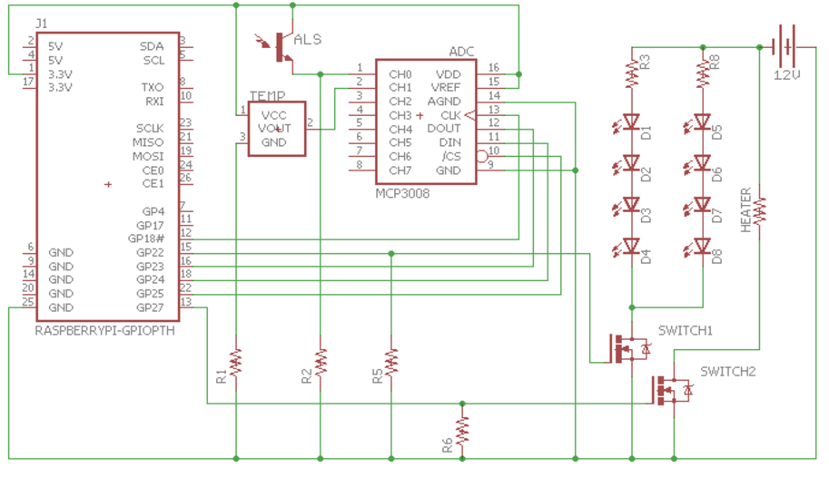

Appendix A : Electrical schematic with all components

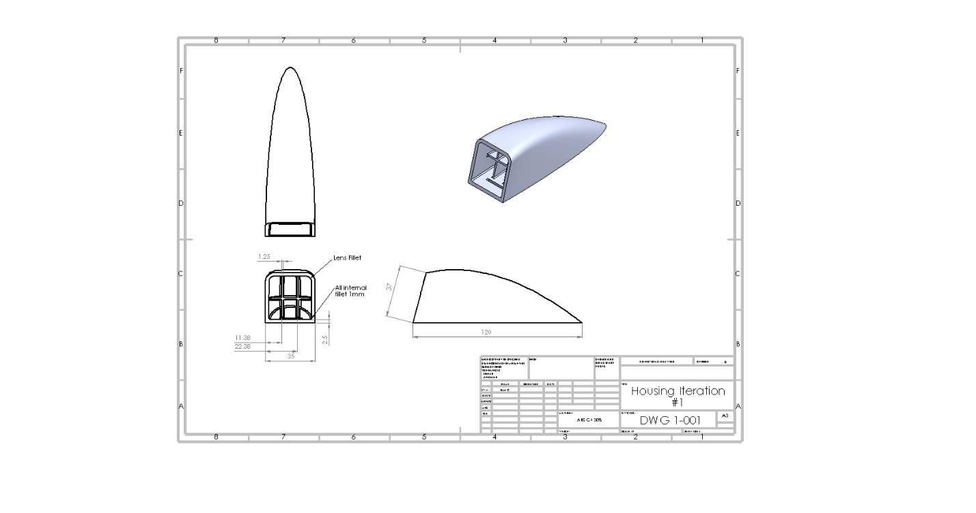

Appendix A : Iteration #1 housing CAD

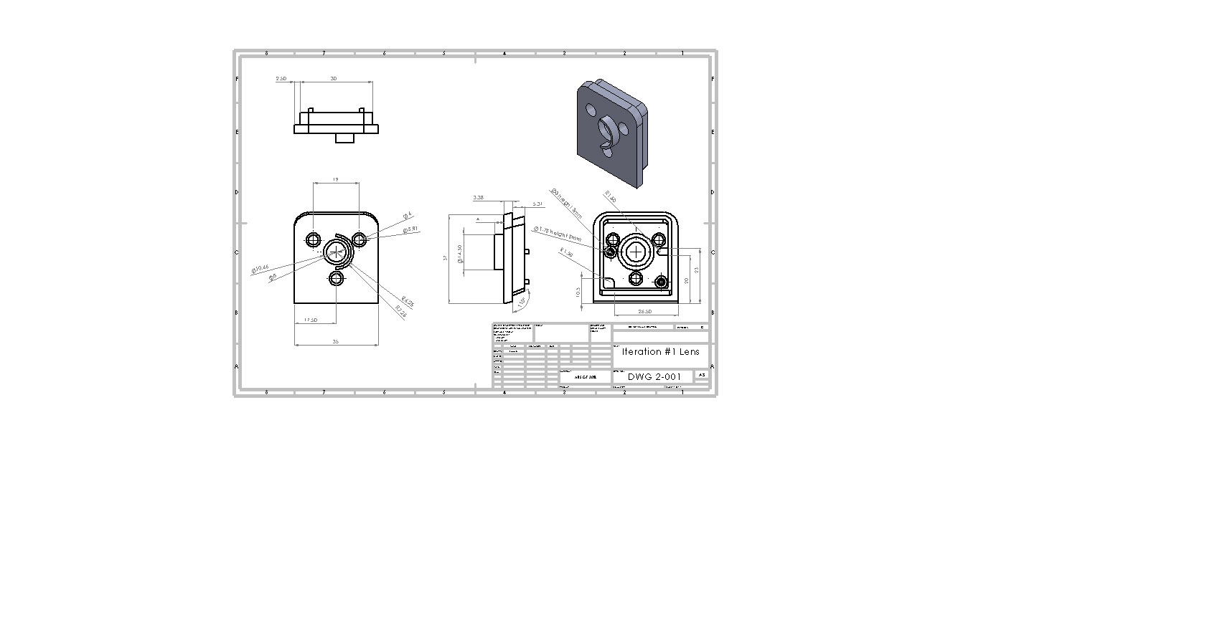

Appendix A : Iteration #1 Lens CAD

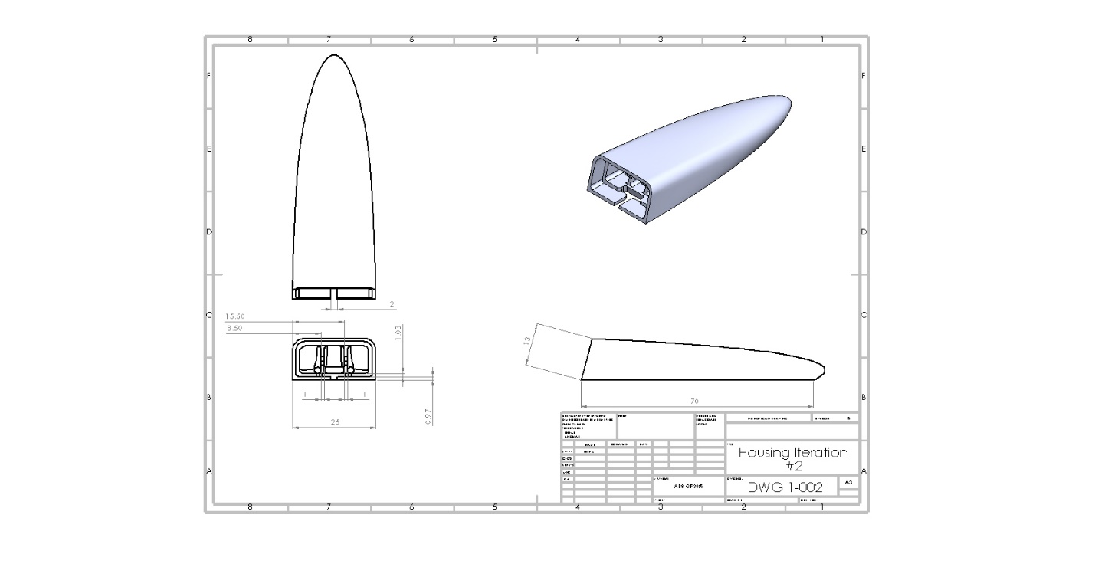

Appendix A : Iteration #2 Housing CAD

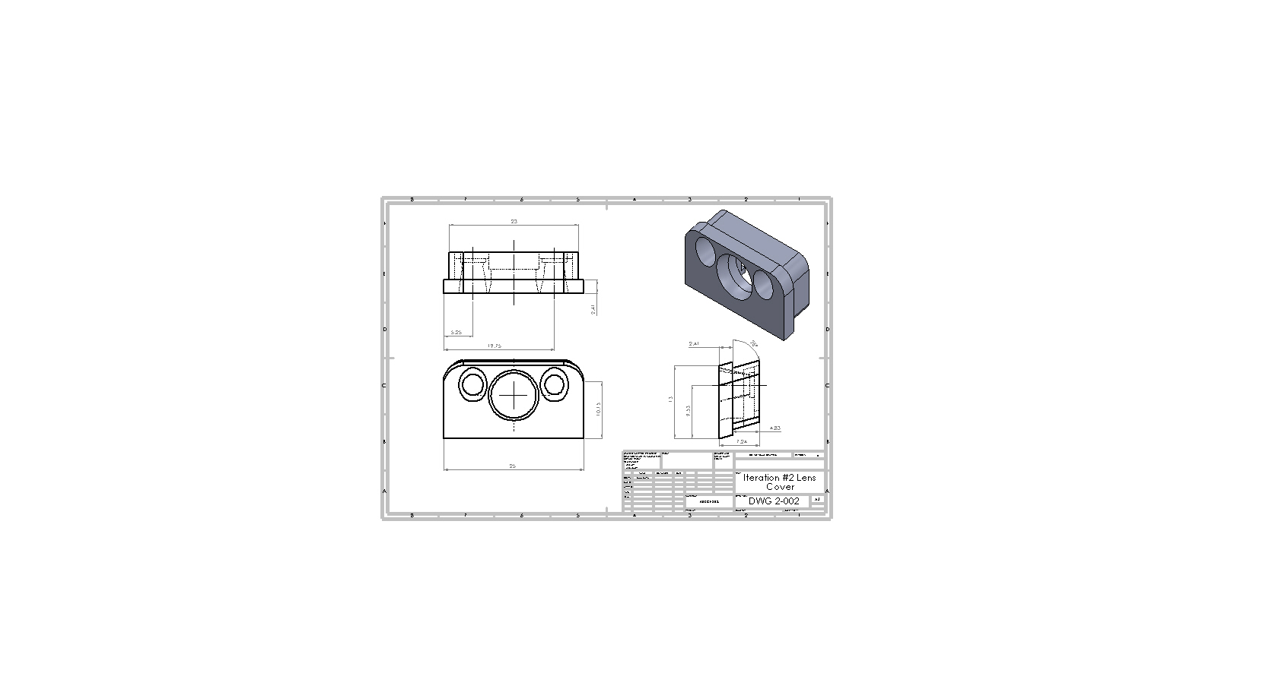

Appendix A : Iteration #2 Lens Cover CAD

# Appendix B: Engineering Design Specifications

**Engineering Design Specification**

Title: Vehicle Indirect Vision System

Number: 18 Revision Level: E

Originator: Team 18 Date: Jan 19, 2017

**Intended Application:**

To improve the drag caused by the side mirror of a vehicle and to increase driver safety by decreasing blind spot zone.

**Requirements Specification:**

|  |  |  |  |  |  |  |
| --- | --- | --- | --- | --- | --- | --- |
| **No.** | **Characteristic** | **Relation** | **Value** | **Unit(s)** | **Verification**  **Method** | **Comments** |
| 1 | Reduction in drag force due to side mirror module | > | 80 | % | Analysis | Should be less than current benchmark |
| 2 | Mass reduction | > | 90 | % | Demo | Less than automotive average benchmark |
| 3 | Field of view | > | 40 | degrees | Demo/Analysis |  |
| 4 | Blind spot reduction | > | 50 | % | Demo/Analysis | Blind spot area defined as 2 lanes away |
| 5 | Strength | > | 140 | N | Analysis/Testing | FMVSS111 S5.1.2 |
| 6 | Cost | < | 2000 | $ | Balance Sheets, |  |
| 7 | Fully Enclosed Electrical System | = | Yes |  | Demo | No wires exposed. |
| 8 | Snag Points | = | 0 |  | Demo/Test |  |
| 9 | Electrical Redundancy | ≥ | 1 |  | Demo/Test |  |
| 10 | Vehicle Fuel Efficiency | > | 2 | % | Simulation/Analysis |  |
| 11 | System Initialization Time | < | 1 | s | Demonstration |  |
| 12 | Loading Safety Factor | = | 1.5 | N/A | Analysis |  |
| 13 | Object tracking (pedestrian and cars) | = | true | N/A | Live demo |  |
| 14 | Operating temperature | within | -20 to 50 | degrees | simulation |  |

# Appendix C: Verification of Design Data

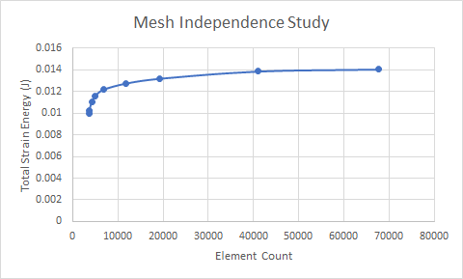

Appendix C 1: Mesh Independence Study FEA Comsol

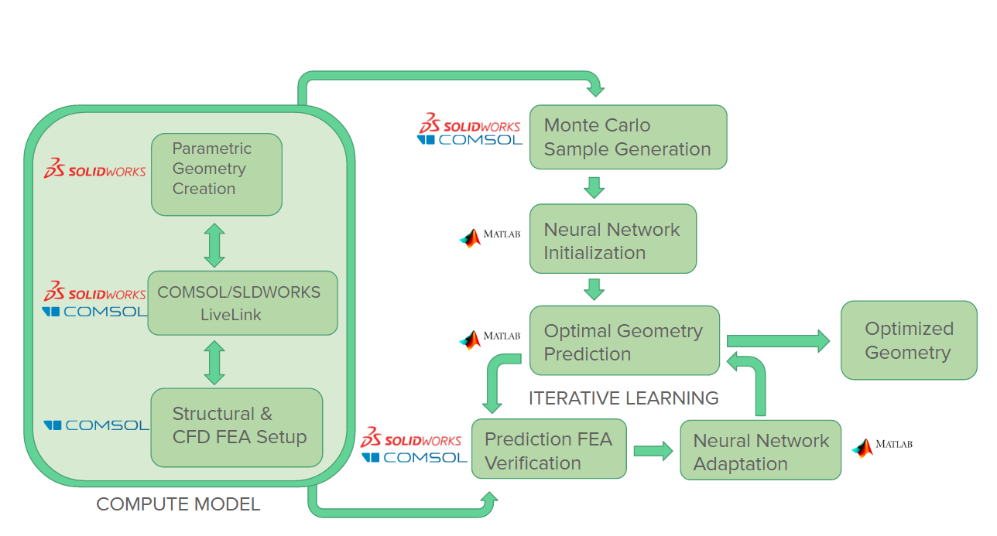

Appendix C : Detailed Neural Network Flowchart

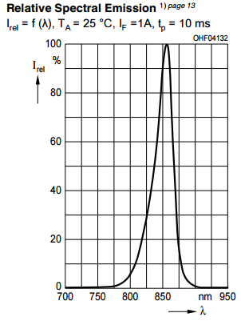

Appendix C : IR Intensity data graph**9**

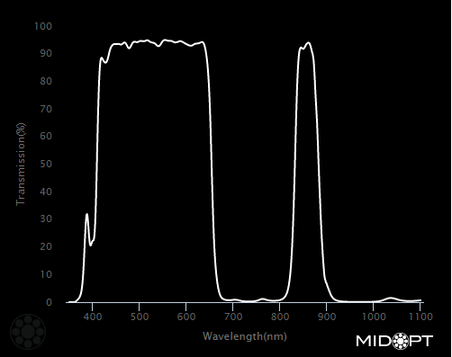

Appendix C : Dual Bandpass filter specification graph**20**

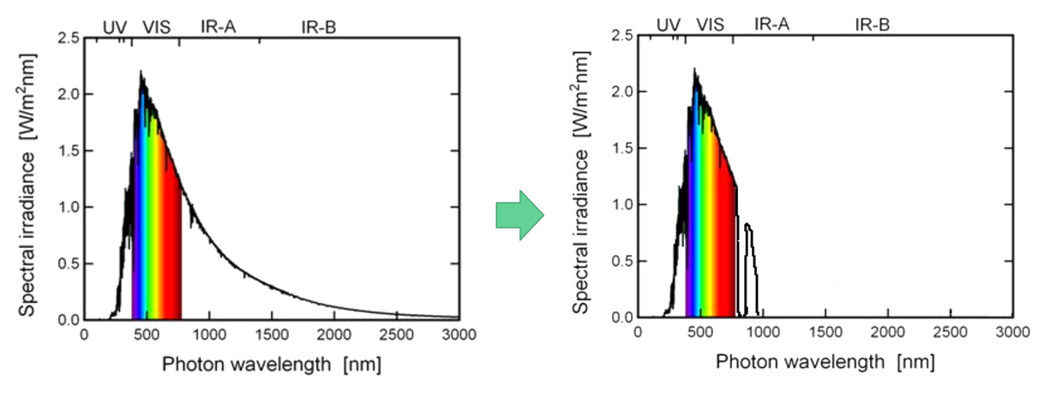

Appendix C : Effects of dual bandpass filter from unrestricted spectrum**21**

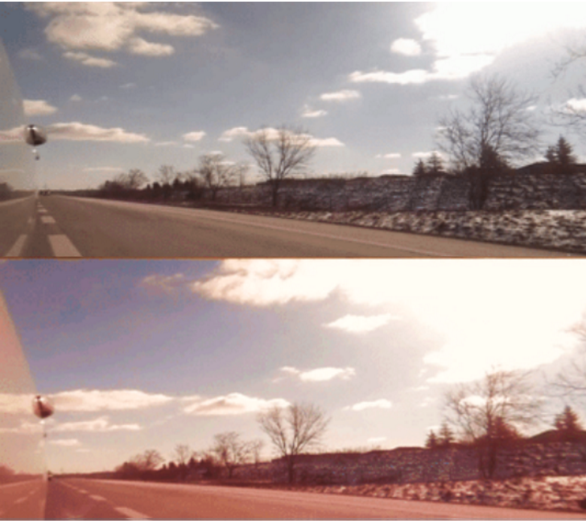

Appendix C : Video feed comparison; filter(top), no filter(bottom)

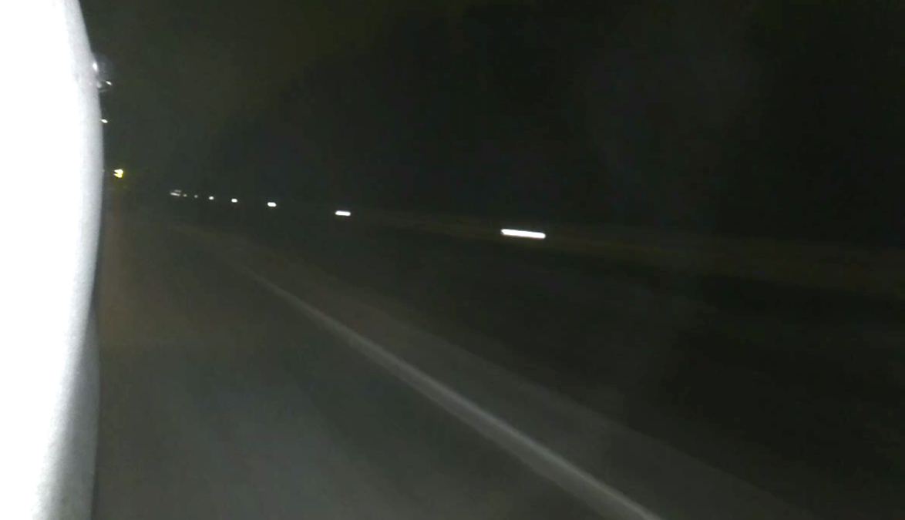

Appendix C : Night time IR demo, highway speeds

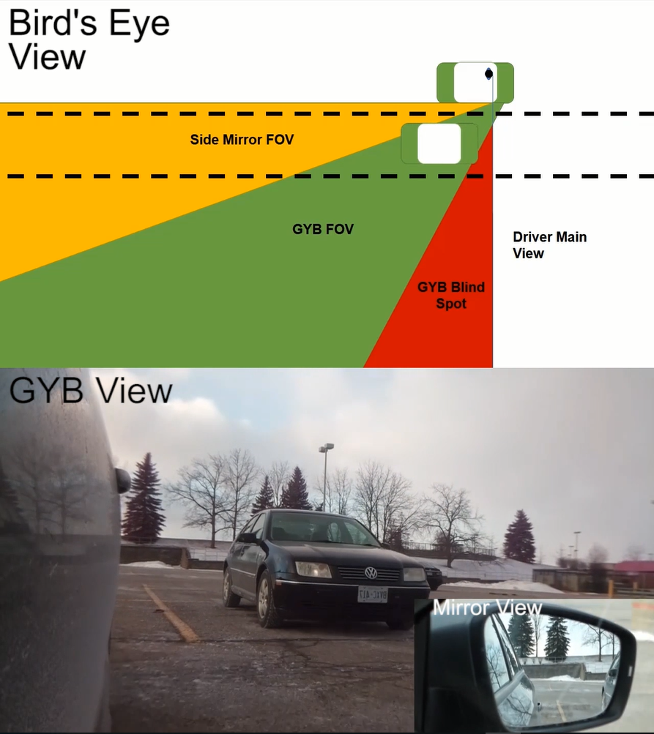

Appendix C : Field of View test, comparing side mirror to video feed.

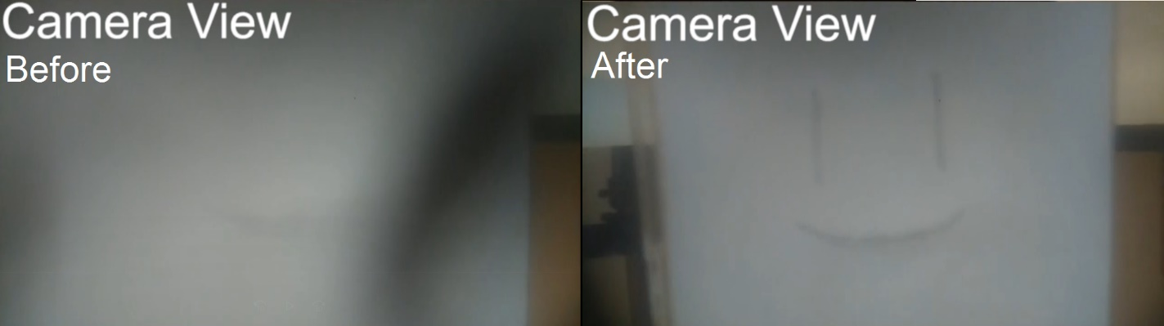

Appendix C : Defrost system test before and after

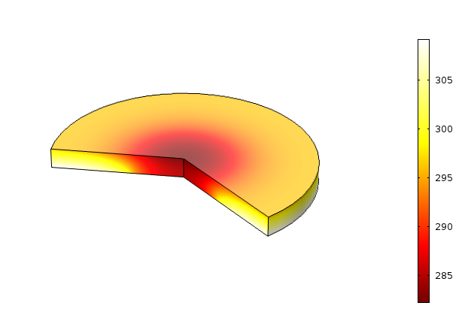

Appendix C : Max Lens Temperature (3 minutes of heating)

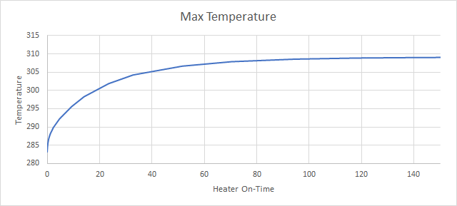

Appendix C : Max temperature of Transparent lens

# Appendix D: Hazard Disclosure Form





# Appendix E: Lessons Learned

ENG_line_cmyk.emf

**Department of Mechanical and Mechatronics Engineering**

**University of Waterloo**

**ME481 Mechanical Engineering Design Project**

**Lessons Learned**

**Student Name:** Sean Corro\_\_\_\_\_\_\_\_\_\_\_\_\_\_\_\_\_\_\_\_\_\_\_\_\_\_\_\_ **Team No.:** 18\_\_\_\_\_\_\_\_\_\_\_\_\_\_\_\_\_\_\_\_\_\_\_

**Course Learning Outcomes**

Upon successful completion of this course, the student will be able to[[1]](#footnote-2):

* Identify, represent and communicate a mechanical engineering problem or opportunity
* Design a mechanical engineering system, product and/or process
* Implement, verify and refine a design
* Identify and address safety, regulatory, sustainability and professional ethics
* Apply project management skills and techniques
* Communicate accurately and effectively

**Assignment**

The purpose of this assignment is for the student to reflect on their learning. This is done in two (2) parts.

In the first part the student is asked to indicate what work, specific deliverables, they produced to demonstrate that they have performed against the intended learning outcomes of the course. For each outcome listed above, there are a number of so-called performance indicators – statements that would indicate what performance dimension is being sought.

The student is asked to complete these tables by providing responses directly into the table, specifically

* What student work was produced to demonstrate performance against each indicator (i.e. report, presentation, drawing, specification document, prototype, analysis, etc)
* Additional questions

In the second part the student is asked to provide a written summary of what they have learned that they did not know about prior to taking the Design Project courses. This is intended to be a more-open-ended exercise for the student to reflect, not just on the learning outcomes above, but any other lessons, knowledge, skills, behaviors etc. that the student found especially useful.

**Design**

* Identify, represent and communicate a mechanical engineering problem or opportunity
* Design a mechanical engineering system, product and/or process
* Implement, verify and refine a design
* Identify and address safety, regulatory, sustainability and professional ethics

|  |  |  |  |
| --- | --- | --- | --- |
| **Performance Indicator** | **List the specific deliverables you produced that demonstrated your performance**  (i.e. Reports, assignments, engineering specification, CAD Model, Analyses etc.) | **What challenges were presented to you in achieving this learning outcome?** | **What is the value of this learning outcome for a future design project task?** |
| Identify needs, function, criteria and constraints for a given design, considering engineering economic, health and safety, environmental and ethical specifications | Benchmarking  Specification research  Research Paper studies  Regulatory studies  Statistical studies  Sector reports | Finding data relevant to just the wing mirror issues on the car. Many of the statistics or research papers were either combined with another issue or looking at a different perspective our team was looking at. | Highly valued. Emphasizes your initial foundation of the project. |
| Identify a solution that satisfies the needs analysis | Engineering specification Rough order magnitude calculations looking to existing benchmarks | Trying to gather enough information to formulate a solution to solve the issue | Address different solutions to the problem. |
| Consider safety, society and sustainability issues in selecting a solution | Statistical studies  Regulatory studies  Sector reports | Finding relevant data that are not conflicting between sources. Also trying to find North American statistics. | Important to see if there are any regulations that you need to comply with to develop a product. |
| Generate detailed implementation specifications, including drawings, tolerances, components, etc. as required | CAD model, Drawings, CAD/Drawing reviews, CAD/drawing revisions. Looking towards benchmark designs/processes to implement mass production features. | With a large design space, there were many aspects of low drag, low mass, manufacturability that all needed to be considered. | Very valuable, it is the basis of what your prototype will be built off. It can also feed into your final design based off feedback on the proto design. |
| Verify the design by implementation, prototype production, bench test validation of key elements, and/or acceptance opinion by recognized expert | Build test, Simulation validation, prototype bench testing. | With many components, the main issue was trying to parallelize the process so to not have one party wait for another to keep the schedule on track. | Verification of the design is very important as it gives an initial outlook to how your final design will work in real life conditions. It makes the design tangible and can be evaluated better for physical installation. |

**Project Management**

* Apply project management skills and techniques

|  |  |  |  |
| --- | --- | --- | --- |
| **Performance Indicator** | **List the specific deliverables you produced that demonstrated your performance**  (i.e. Reports, assignments etc.) | **What challenges were presented to you in achieving this learning outcome?** | **What is the value of this learning outcome for a future design project task?** |
| Decompose a project into a manageable set of objectives and/or tasks | Separated project into its different major silos. Separated those silos into milestones for 482. | Trying to plan for contingency and thinking of risk that might occur during the scheduling period. | It sets achievable expectations and helps to have the team on the same page in terms of where the project is and where it needs to go. |
| Develop and track a schedule with milestones | Weekly tasks, multiple meetings per week. | Keeping the schedule updated once the initial schedule was set. | The schedule evaluates if the team is on track to the target. It is important to show the total progress. |
| Manage financial, human and/or physical resources | Budget | Allocating enough budget to each silo on the team. | Budget keeps the project on track to the given resources we are allocated and raises the question if some items are necessary to buy. |
| Identify and manage risks | Risk Register | How to account for risk in the future | This is very valuable since not being able to plan for contingency can make or break a project. |
| Apply change management | Team meetings for altered responsibilities | Managing a comfortable level of work for the team without overworking one person/persons. | Change management allows the team to be dynamic for future. |

**Communication**

* Communicate accurately and effectively

|  |  |  |  |
| --- | --- | --- | --- |
| **Performance Indicator** | **List the specific deliverables you produced that demonstrated your performance**  (i.e. Reports, assignments etc.) | **What challenges were presented to you in achieving this learning outcome?** | **What is the value of this learning outcome for a future design project task?** |
| Write effective reports and design documentation | Reports, presentations | Being concise but have enough breadth to explore a problem. | Allows the individual to be more to the point and only communicate the most important aspects of the project. |
| Make effective presentations | Presentation | Placing on the important information. Keeping presentation on time. | Keeps a clean and easy to understand overview of the project and what has happened over the course. |

**More Lessons Learned**

During FYDP there were a handful of different areas that were new to me. The most impactful area of the project, was the use of statistics/machine learning to optimize for a design process. During our mechanical statistics course, there was limited application towards mechanical design and verification. This project and with the help of the design competition helped me to understand how to use data and information in a smart way to leverage computing power to solve a design problem.

ENG_line_cmyk.emf

**Department of Mechanical and Mechatronics Engineering**

**University of Waterloo**

**ME481 Mechanical Engineering Design Project**

**Lessons Learned**

**Student Name:** \_\_\_\_\_\_KELVIN CHOW\_\_\_\_\_\_\_\_\_\_\_\_ **Team No.:** \_\_\_\_\_\_\_\_\_\_\_18\_\_\_\_\_\_\_\_\_\_\_\_

**Course Learning Outcomes**

Upon successful completion of this course, the student will be able to[[2]](#footnote-3):

* Identify, represent and communicate a mechanical engineering problem or opportunity
* Design a mechanical engineering system, product and/or process
* Implement, verify and refine a design
* Identify and address safety, regulatory, sustainability and professional ethics
* Apply project management skills and techniques
* Communicate accurately and effectively

**Assignment**

The purpose of this assignment is for the student to reflect on their learning. This is done in two (2) parts.

In the first part the student is asked to indicate what work, specific deliverables, they produced to demonstrate that they have performed against the intended learning outcomes of the course. For each outcome listed above, there are a number of so-called performance indicators – statements that would indicate what performance dimension is being sought.

The student is asked to complete these tables by providing responses directly into the table, specifically

* What student work was produced to demonstrate performance against each indicator (i.e. report, presentation, drawing, specification document, prototype, analysis, etc)
* Additional questions

In the second part the student is asked to provide a written summary of what they have learned that they did not know about prior to taking the Design Project courses. This is intended to be a more-open-ended exercise for the student to reflect, not just on the learning outcomes above, but any other lessons, knowledge, skills, behaviors etc. that the student found especially useful.

**Design**

* Identify, represent and communicate a mechanical engineering problem or opportunity
* Design a mechanical engineering system, product and/or process
* Implement, verify and refine a design
* Identify and address safety, regulatory, sustainability and professional ethics

|  |  |  |  |
| --- | --- | --- | --- |
| **Performance Indicator** | **List the specific deliverables you produced that demonstrated your performance**  (i.e. Reports, assignments, engineering specification, CAD Model, Analyses etc.) | **What challenges were presented to you in achieving this learning outcome?** | **What is the value of this learning outcome for a future design project task?** |
| Identify needs, function, criteria and constraints for a given design, considering engineering economic, health and safety, environmental and ethical specifications | Engineering design specifications  Report writing | Defining the right project scope. Too large would be challenging. Too small would be limiting. | Always refer back to the needs analysis or else the solution will stray away from the initial problem it is trying to solve. |
| Identify a solution that satisfies the needs analysis | Brainstorming sessions  Report Writing | Deciding between a solution that we can accomplish vs. a solution that we want to accomplish | We can’t always have what we want, so sometimes we have to pick and choose what is attainable. |
| Consider safety, society and sustainability issues in selecting a solution | Brainstorming sessions  Report Writing | Sometimes, this concept, although very important, gets forgotten | Safety, society, and sustainability is very important. We should always remember why we are doing what we are doing. |
| Generate detailed implementation specifications, including drawings, tolerances, components, etc. as required | Electrical schematics | Not knowing how to use software. | Could have used simulation tools (SPICE) while designing schematics. It would have helped identify problems that were discovered while prototyping. |
| Verify the design by implementation, prototype production, bench test validation of key elements, and/or acceptance opinion by recognized expert | Testing of night time and camera FOV | Determining how to conduct a test to best present it to validate it to others. | Testing requires more preparation than originally thought. |

**Project Management**

* Apply project management skills and techniques

|  |  |  |  |
| --- | --- | --- | --- |
| **Performance Indicator** | **List the specific deliverables you produced that demonstrated your performance**  (i.e. Reports, assignments etc.) | **What challenges were presented to you in achieving this learning outcome?** | **What is the value of this learning outcome for a future design project task?** |
| Decompose a project into a manageable set of objectives and/or tasks | Initial project planning | Shit happens. Things change. | Be flexible. Plan for the worst. Always have a contingency plan. |
| Develop and track a schedule with milestones | Initial work break down schedule | Hard to stick to a schedule | Have a more flexible schedule. Make sure work hours are met and review progress on a weekly basis. |
| Manage financial, human and/or physical resources | Managed personal receipts  Tracked budget | Be careful of how receipts are stored. Some fade away and I can`t get the expense reimbursed ☹. | Take care of receipts better. |
| Identify and manage risks | Risk register  Contingency planning | Some risks do not have mitigation plans. They are essential to the outcome of the project | Focus on the important risks, others need to managed as best as possible. |
| Apply change management | Kept track of revision of documents | Nothing. | Always important to keep old documents in case plans change. |

**Communication**

* Communicate accurately and effectively

|  |  |  |  |
| --- | --- | --- | --- |
| **Performance Indicator** | **List the specific deliverables you produced that demonstrated your performance**  (i.e. Reports, assignments etc.) | **What challenges were presented to you in achieving this learning outcome?** | **What is the value of this learning outcome for a future design project task?** |
| Write effective reports and design documentation | Report | 20 pages is very little. Choosing the most important parts of the project to write about. | Conveying ideas clearly with limited space. |
| Make effective presentations | Design review presentations | Effectively presenting all our ideas in the given time frame | Decide what is most important to present, and go from there. |

**Other Lessons-Learned**

This project taught me a lot in terms of technical skills, teamwork skills, and valuable life lessons.

I took on some of the electrical portion of this project, which was something I had limited experience with in the past. I was able to learn about electrical design, PCB design and prototyping. Through the nature of this project, I also gained a lot of insight on optics, design and analysis tools.

Design courses like this give an opportunity for me to be a part of something very rare in industry. The whole team is made up (in our case) of five people who are responsible of the whole process of the project. If the project was taken on by a company, a team of engineers would take on the housing design, a team would take on electrical design, another group would do the software, and you would have PMs and administrative staff to do everything in between. This project gives us an opportunity to see the entire engineering process and get an understanding of how different teams work together through an interdisciplinary project.

ENG_line_cmyk.emf

**Department of Mechanical and Mechatronics Engineering**

**University of Waterloo**

**ME481 Mechanical Engineering Design Project**

**Lessons Learned**

**Student Name:** Peter Zhang\_\_\_\_\_\_\_\_\_\_\_\_\_\_\_\_\_\_\_\_\_\_\_\_\_\_\_ **Team No.:** 18\_\_\_\_\_\_\_\_\_\_\_\_\_\_\_\_\_\_\_\_\_\_

**Course Learning Outcomes**

Upon successful completion of this course, the student will be able to[[3]](#footnote-4):

* Identify, represent and communicate a mechanical engineering problem or opportunity
* Design a mechanical engineering system, product and/or process
* Implement, verify and refine a design
* Identify and address safety, regulatory, sustainability and professional ethics
* Apply project management skills and techniques
* Communicate accurately and effectively

**Assignment**

The purpose of this assignment is for the student to reflect on their learning. This is done in two (2) parts.

In the first part the student is asked to indicate what work, specific deliverables, they produced to demonstrate that they have performed against the intended learning outcomes of the course. For each outcome listed above, there are a number of so-called performance indicators – statements that would indicate what performance dimension is being sought.

The student is asked to complete these tables by providing responses directly into the table, specifically

* What student work was produced to demonstrate performance against each indicator (i.e. report, presentation, drawing, specification document, prototype, analysis, etc)
* Additional questions

In the second part the student is asked to provide a written summary of what they have learned that they did not know about prior to taking the Design Project courses. This is intended to be a more-open-ended exercise for the student to reflect, not just on the learning outcomes above, but any other lessons, knowledge, skills, behaviors etc. that the student found especially useful.

**Design**

* Identify, represent and communicate a mechanical engineering problem or opportunity
* Design a mechanical engineering system, product and/or process
* Implement, verify and refine a design
* Identify and address safety, regulatory, sustainability and professional ethics

|  |  |  |  |
| --- | --- | --- | --- |
| **Performance Indicator** | **List the specific deliverables you produced that demonstrated your performance**  (i.e. Reports, assignments, engineering specification, CAD Model, Analyses etc.) | **What challenges were presented to you in achieving this learning outcome?** | **What is the value of this learning outcome for a future design project task?** |
| Identify needs, function, criteria and constraints for a given design, considering engineering economic, health and safety, environmental and ethical specifications | Researching existing solutions.  Researching reliability of existing software solutions.  Report writing. | Not many existing solutions operate in exactly the same way as the way we intended. Difficult to research. | This is important to understand how much work is required for the software portion of the project. |
| Identify a solution that satisfies the needs analysis | Engineering specifications.  Brainstorming solutions.  Researching existing solutions. | Not a lot of experience in the area means that we aren’t sure which brainstormed solutions are most difficult to implement. | Same as above. Helps in understanding how much work is required. |
| Consider safety, society and sustainability issues in selecting a solution | Evaluating brainstormed solutions.  Research object tracking.  Report writing. | New ideas may be impossible to implement or may be very inconsistent, and it’s not immediately obvious. | Incredibly important for any possible future for the project. Emphasis on safety is important in a project in which the original criteria is to increase safety. |
| Generate detailed implementation specifications, including drawings, tolerances, components, etc. as required | Software flowcharts.  Generate code backbone structures. | Not a lot of experience with OpenCV means that we relied heavily on existing projects which are not entirely the same as our project. | Develops programming skills that may be useful for future projects. Gain understanding of limitations of current software and hardware. |
| Verify the design by implementation, prototype production, bench test validation of key elements, and/or acceptance opinion by recognized expert | Test software programs against pre-recorded videos. | Difficult to test software program without actually installing design on side of car and getting footage of what the camera sensor sees. As a result, we were coding blindly. | Important for the project since it gives insight for whether or not the solution will work for various situations. |

**Project Management**

* Apply project management skills and techniques

|  |  |  |  |
| --- | --- | --- | --- |
| **Performance Indicator** | **List the specific deliverables you produced that demonstrated your performance**  (i.e. Reports, assignments etc.) | **What challenges were presented to you in achieving this learning outcome?** | **What is the value of this learning outcome for a future design project task?** |
| Decompose a project into a manageable set of objectives and/or tasks | Project decomposition.  Milestone planning. | Have to predict all possible obstacles, which is difficult. | Gaining experience in planning helps all future projects. This project was particularly difficult to plan, so it was a great learning experience. |
| Develop and track a schedule with milestones | Workflow breakdown schedule. | Difficult to determine how much work is required since a lot of the project is new territory. | Same as above. |
| Manage financial, human and/or physical resources | Record all expenditures.  Record hours in timesheets. | Generally forget to record hours.  Large amount of expenditures. | Important for financial management. Good for expense tracking. |
| Identify and manage risks | Developing risk register.  Contingency. | Software is essential to the project, but all possible solutions to the risks contain more risks since we have little experience with software. | Same as above. |
| Apply change management | Not much. | N/A | N/A |

**Communication**

* Communicate accurately and effectively

|  |  |  |  |
| --- | --- | --- | --- |
| **Performance Indicator** | **List the specific deliverables you produced that demonstrated your performance**  (i.e. Reports, assignments etc.) | **What challenges were presented to you in achieving this learning outcome?** | **What is the value of this learning outcome for a future design project task?** |
| Write effective reports and design documentation | Report writing. | Planning the report is difficult since there is a length limit. | Providing information in a concise manner. |
| Make effective presentations | All presentations done. | Similar to above. Some information is not good to present since it is more confusing than informative. | Developing good presentation skills. |

**Other Lessons-Learned**

Most of my designs learned have to do with the technical information involved with programming and libraries. Lots of information is available on the internet such as documentation and existing open source projects, but nothing is exactly the same as a complex project like ours, which means that I had to extract information from those existing source codes and compile it into our own project.

ENG_line_cmyk.emf

**Department of Mechanical and Mechatronics Engineering**

**University of Waterloo**

**ME481 Mechanical Engineering Design Project**

**Lessons Learned**

**Student Name:** \_\_\_\_\_\_\_Jame Sun\_\_\_\_\_\_\_\_\_\_\_\_\_\_\_\_\_\_ **Team No.:** \_\_\_\_18\_\_\_\_\_\_\_\_\_\_\_\_\_\_\_

**Course Learning Outcomes**

Upon successful completion of this course, the student will be able to[[4]](#footnote-5):

* Identify, represent and communicate a mechanical engineering problem or opportunity
* Design a mechanical engineering system, product and/or process
* Implement, verify and refine a design
* Identify and address safety, regulatory, sustainability and professional ethics
* Apply project management skills and techniques
* Communicate accurately and effectively

**Assignment**

The purpose of this assignment is for the student to reflect on their learning. This is done in two (2) parts.

In the first part the student is asked to indicate what work, specific deliverables, they produced to demonstrate that they have performed against the intended learning outcomes of the course. For each outcome listed above, there are a number of so-called performance indicators – statements that would indicate what performance dimension is being sought.

The student is asked to complete these tables by providing responses directly into the table, specifically

* What student work was produced to demonstrate performance against each indicator (i.e. report, presentation, drawing, specification document, prototype, analysis, etc)
* Additional questions

In the second part the student is asked to provide a written summary of what they have learned that they did not know about prior to taking the Design Project courses. This is intended to be a more-open-ended exercise for the student to reflect, not just on the learning outcomes above, but any other lessons, knowledge, skills, behaviors etc. that the student found especially useful.

**Design**

* Identify, represent and communicate a mechanical engineering problem or opportunity
* Design a mechanical engineering system, product and/or process
* Implement, verify and refine a design
* Identify and address safety, regulatory, sustainability and professional ethics

|  |  |  |  |
| --- | --- | --- | --- |
| **Performance Indicator** | **List the specific deliverables you produced that demonstrated your performance**  (i.e. Reports, assignments, engineering specification, CAD Model, Analyses etc.) | **What challenges were presented to you in achieving this learning outcome?** | **What is the value of this learning outcome for a future design project task?** |
| Identify needs, function, criteria and constraints for a given design, considering engineering economic, health and safety, environmental and ethical specifications | Helped identify design and analysis goals for the housing, both exterior shapes and interior structure, which directly correlate to CO2 emission. | It was difficult to quantify the exact environmental benefits as the side mirror’s environmental impact was not well studied. In the end we settled for drag reduction instead. | Resourcefulness is important for when key data is missing as it can almost always be inferred some other way |
| Identify a solution that satisfies the needs analysis | Constructed and realized the neural network analysis workflow | In the beginning, I had an idea of what I wanted to do but no clue on how to actually do it | I consulted one of my friend who was into machine learning to get started, which shows that interdisciplinary communication is very important |
| Consider safety, society and sustainability issues in selecting a solution | Contributed to the design of IR vision by selecting the dualband bandpass filter | In the beginning, our solution would have costed us $300, and it seemed like we didn’t have any other method | Thorough research should be done before procurement as a much cheaper option may be available |
| Generate detailed implementation specifications, including drawings, tolerances, components, etc. as required | N/A, another team member did this task and I was only concerned with analysis | N/A | N/A |
| Verify the design by implementation, prototype production, bench test validation of key elements, and/or | Assisted in drive testing to verify the camera specs. | We didn’t know the NOIR camera was going to have a red taint until we actually drive tested it | Incremental testing should be done early and frequently |
| Acceptance opinion by recognized expert | Consulted professor Chris Backhouse regarding neural network difficulties | The neural network was not searching for the best possible solution | Some agitation is required for genetic algorithm so that a less favored path is taken once in a while |

**Project Management**

* Apply project management skills and techniques

|  |  |  |  |
| --- | --- | --- | --- |
| **Performance Indicator** | **List the specific deliverables you produced that demonstrated your performance**  (i.e. Reports, assignments etc.) | **What challenges were presented to you in achieving this learning outcome?** | **What is the value of this learning outcome for a future design project task?** |
| Decompose a project into a manageable set of objectives and/or tasks | Decomposed to neural network tasks for ANSYS design analytics competition into components to be completed individually | No challenges was encountered | Decomposing a project into smaller tasks definitely helped manage my stress level |
| Develop and track a schedule with milestones | N/A, I did not have to adhere to a strict schedule as I’d always complete the deliverables before the deadline | N/A | N/A |
| Manage financial, human and/or physical resources | Managed receipts for financial reimbursement | Some receipts went missing | It’s important to keep track of all receipts so that they can be reimbursed in the end |
| Identify and manage risks | Identified risk associated with optimization methods | Some methods failed to produce good results and I wasn’t sure if I should keep trying | Neural network is a wonderful tool that will probably become very common in the next 10 years |
| Apply change management | Changed optimization method from traditional to neural network | See above | Change should be made readily and early so there is enough time to adapt to difficulties |

**Communication**

* Communicate accurately and effectively

|  |  |  |  |
| --- | --- | --- | --- |
| **Performance Indicator** | **List the specific deliverables you produced that demonstrated your performance**  (i.e. Reports, assignments etc.) | **What challenges were presented to you in achieving this learning outcome?** | **What is the value of this learning outcome for a future design project task?** |
| Write effective reports and design documentation | Completed sections of this report as well as documentations for the ANSYS design competition | N/A | N/A |
| Make effective presentations | Compiled the ANSYS design competition | It was difficult to keep the presentation under 15 minutes | A presentation should only consist of the absolute essential information |

**Other Lessons-Learned**

I was mostly involved with the analysis and neural network aspects of this project so my lessons learned will be related to those areas.

I learned that compared to traditional methods, neural network is establishing itself as the new norm for a variety of task like analysis. Neural network is basically capable of most analysis tasks except that it will do it better, and more efficiently. Take regression for example, we tried traditional linear regression fits using matlab or excel but it didn’t work due to the noisy and large set. Neural network was able to resolve the regression in matter of seconds to a very high degree of accuracy. I think that in the future neural network will become a common tool for science and engineering and it will be as accessible as excel functions.

Besides analysis, I learned that it’s best to do everything beforehand as opposed to right before the deadline. It not only makes stress more manageable but gives us more flexibility in case something else arises.

ENG_line_cmyk.emf

**Department of Mechanical and Mechatronics Engineering**

**University of Waterloo**

**ME481 Mechanical Engineering Design Project**

**Lessons Learned**

**Student Name:** \_Xu Hua Tian\_\_\_\_\_\_\_\_\_\_\_\_\_\_\_\_\_\_\_\_\_\_\_\_ **Team No.:** \_18\_\_\_\_\_\_\_\_\_\_\_\_\_\_\_\_\_\_\_\_\_\_\_\_

**Course Learning Outcomes**

Upon successful completion of this course, the student will be able to[[5]](#footnote-6):

* Identify, represent and communicate a mechanical engineering problem or opportunity
* Design a mechanical engineering system, product and/or process
* Implement, verify and refine a design
* Identify and address safety, regulatory, sustainability and professional ethics
* Apply project management skills and techniques
* Communicate accurately and effectively

**Assignment**

The purpose of this assignment is for the student to reflect on their learning. This is done in two (2) parts.

In the first part the student is asked to indicate what work, specific deliverables, they produced to demonstrate that they have performed against the intended learning outcomes of the course. For each outcome listed above, there are a number of so-called performance indicators – statements that would indicate what performance dimension is being sought.

The student is asked to complete these tables by providing responses directly into the table, specifically

* What student work was produced to demonstrate performance against each indicator (i.e. report, presentation, drawing, specification document, prototype, analysis, etc)
* Additional questions

In the second part the student is asked to provide a written summary of what they have learned that they did not know about prior to taking the Design Project courses. This is intended to be a more-open-ended exercise for the student to reflect, not just on the learning outcomes above, but any other lessons, knowledge, skills, behaviors etc. that the student found especially useful.

**Design**

* Identify, represent and communicate a mechanical engineering problem or opportunity
* Design a mechanical engineering system, product and/or process
* Implement, verify and refine a design
* Identify and address safety, regulatory, sustainability and professional ethics

|  |  |  |  |
| --- | --- | --- | --- |
| **Performance Indicator** | **List the specific deliverables you produced that demonstrated your performance**  (i.e. Reports, assignments, engineering specification, CAD Model, Analyses etc.) | **What challenges were presented to you in achieving this learning outcome?** | **What is the value of this learning outcome for a future design project task?** |
| Identify needs, function, criteria and constraints for a given design, considering engineering economic, health and safety, environmental and ethical specifications | FOV problem identification  Lens frosting problem identification | Creating specifications | Base specifications on previous systems or calculations |
| Identify a solution that satisfies the needs analysis | FOV requirements Defrost heater requirements | Choosing between solutions | Create a decision matrix early |
| Consider safety, society and sustainability issues in selecting a solution | Generated FOV required for blind spots | Finding accurate information on lane width | Double check all base assumptions to make sure multiple sources give same values |
| Generate detailed implementation specifications, including drawings, tolerances, components, etc. as required | Heater specifications  Heater selection and system design | Selecting installation method that is within budget and acceptable schedule | Design systems with assembly in mind.  i.e. change design decision to ensure easy installation |
| Verify the design by implementation, prototype production, bench test validation of key elements, and/or acceptance opinion by recognized expert | Defrost verification through testing | Ensuring consistent freeze on lens  Measuring heat output of heater | Obtain all equipment and verify equipment is working before proceeding to tests |

**Project Management**

* Apply project management skills and techniques

|  |  |  |  |
| --- | --- | --- | --- |
| **Performance Indicator** | **List the specific deliverables you produced that demonstrated your performance**  (i.e. Reports, assignments etc.) | **What challenges were presented to you in achieving this learning outcome?** | **What is the value of this learning outcome for a future design project task?** |
| Decompose a project into a manageable set of objectives and/or tasks | Work breakdown structure  Identification of all major tasks | Identifying all tasks that spawn from other tasks | Be flexible and update plans accordingly when situations change |
| Develop and track a schedule with milestones | Gantt chart | Properly allocating proper amounts of time to each task | Use previous experiences to gauge the time needed for tasks |
| Manage financial, human and/or physical resources | Initial budget estimate | Accurately gauging each items expenses after contingencies | Expect failures and broken parts on top of repairs |
| Identify and manage risks | Risk register | Identifying and rating risks | Size scope to minimize risks of not completing tasks |
| Apply change management | N/A | N/A | N/A |

**Communication**

* Communicate accurately and effectively

|  |  |  |  |
| --- | --- | --- | --- |
| **Performance Indicator** | **List the specific deliverables you produced that demonstrated your performance**  (i.e. Reports, assignments etc.) | **What challenges were presented to you in achieving this learning outcome?** | **What is the value of this learning outcome for a future design project task?** |
| Write effective reports and design documentation | Report writing | Collecting all relevant documents and figures | Keep track of all work done and organize properly for easy access |
| Make effective presentations | Presenting design reviews | Balancing review and updated content | Make sure to present enough and only enough old content to refresh listeners’ memories |

**Other Lessons-Learned**

ME 482 gives the chance for aspiring engineers to grow tremendously in technical and inter-personal aspects. In the technical front, I was able to learn of the impact that artificial neural networks are able to have on traditional engineering fields like computational fluid dynamics and finite element stress analysis. In addition, I’ve learned a great deal about project management. Always carefully consider all tasks and their impact on other tasks when planning contingencies. Overall, this course was a great learning experience.

# Appendix F: Prototype Images

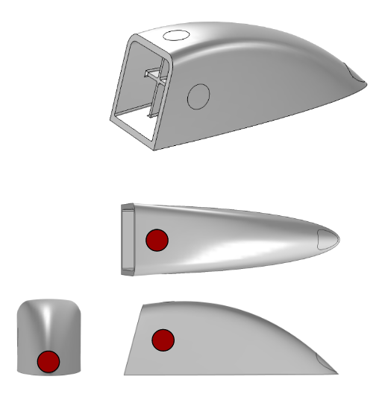

Appendix F : 3 axis load case for FEA

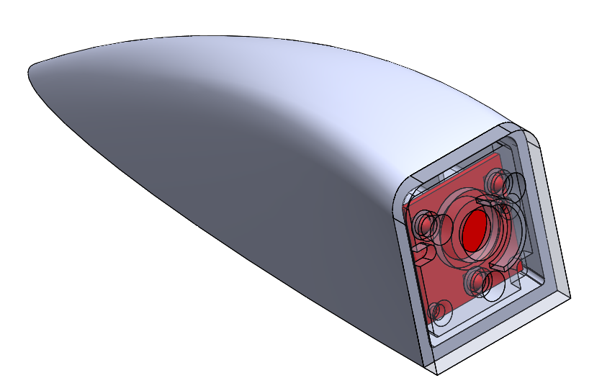

Appendix F : Camera constraining exterior housing width and lens height

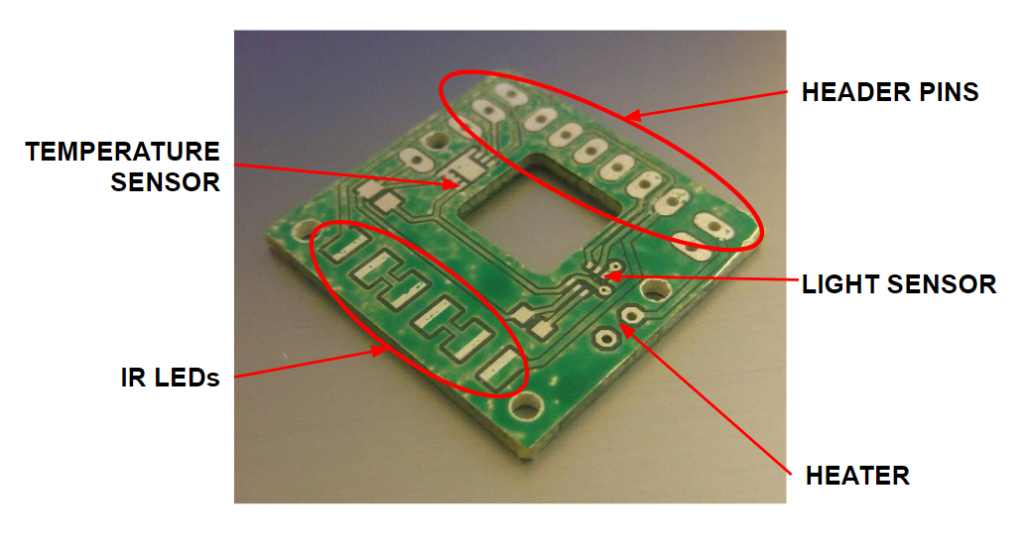

Appendix F : PCB layout showing contact pads for components

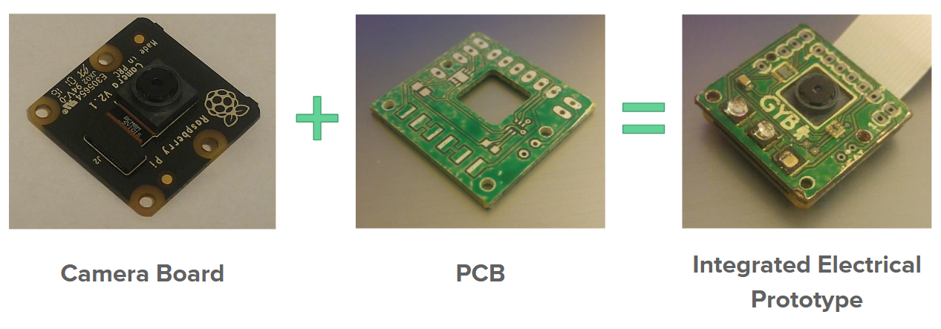

Appendix F : PCB overlay on camera showing packaging

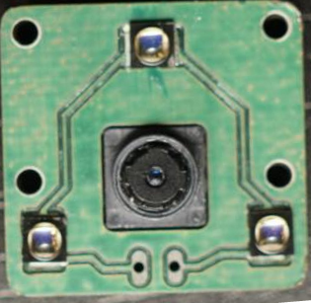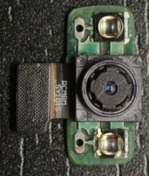

Appendix F : final PCB and camera prototypes; iteration #1 (left), iteration #2 (right)

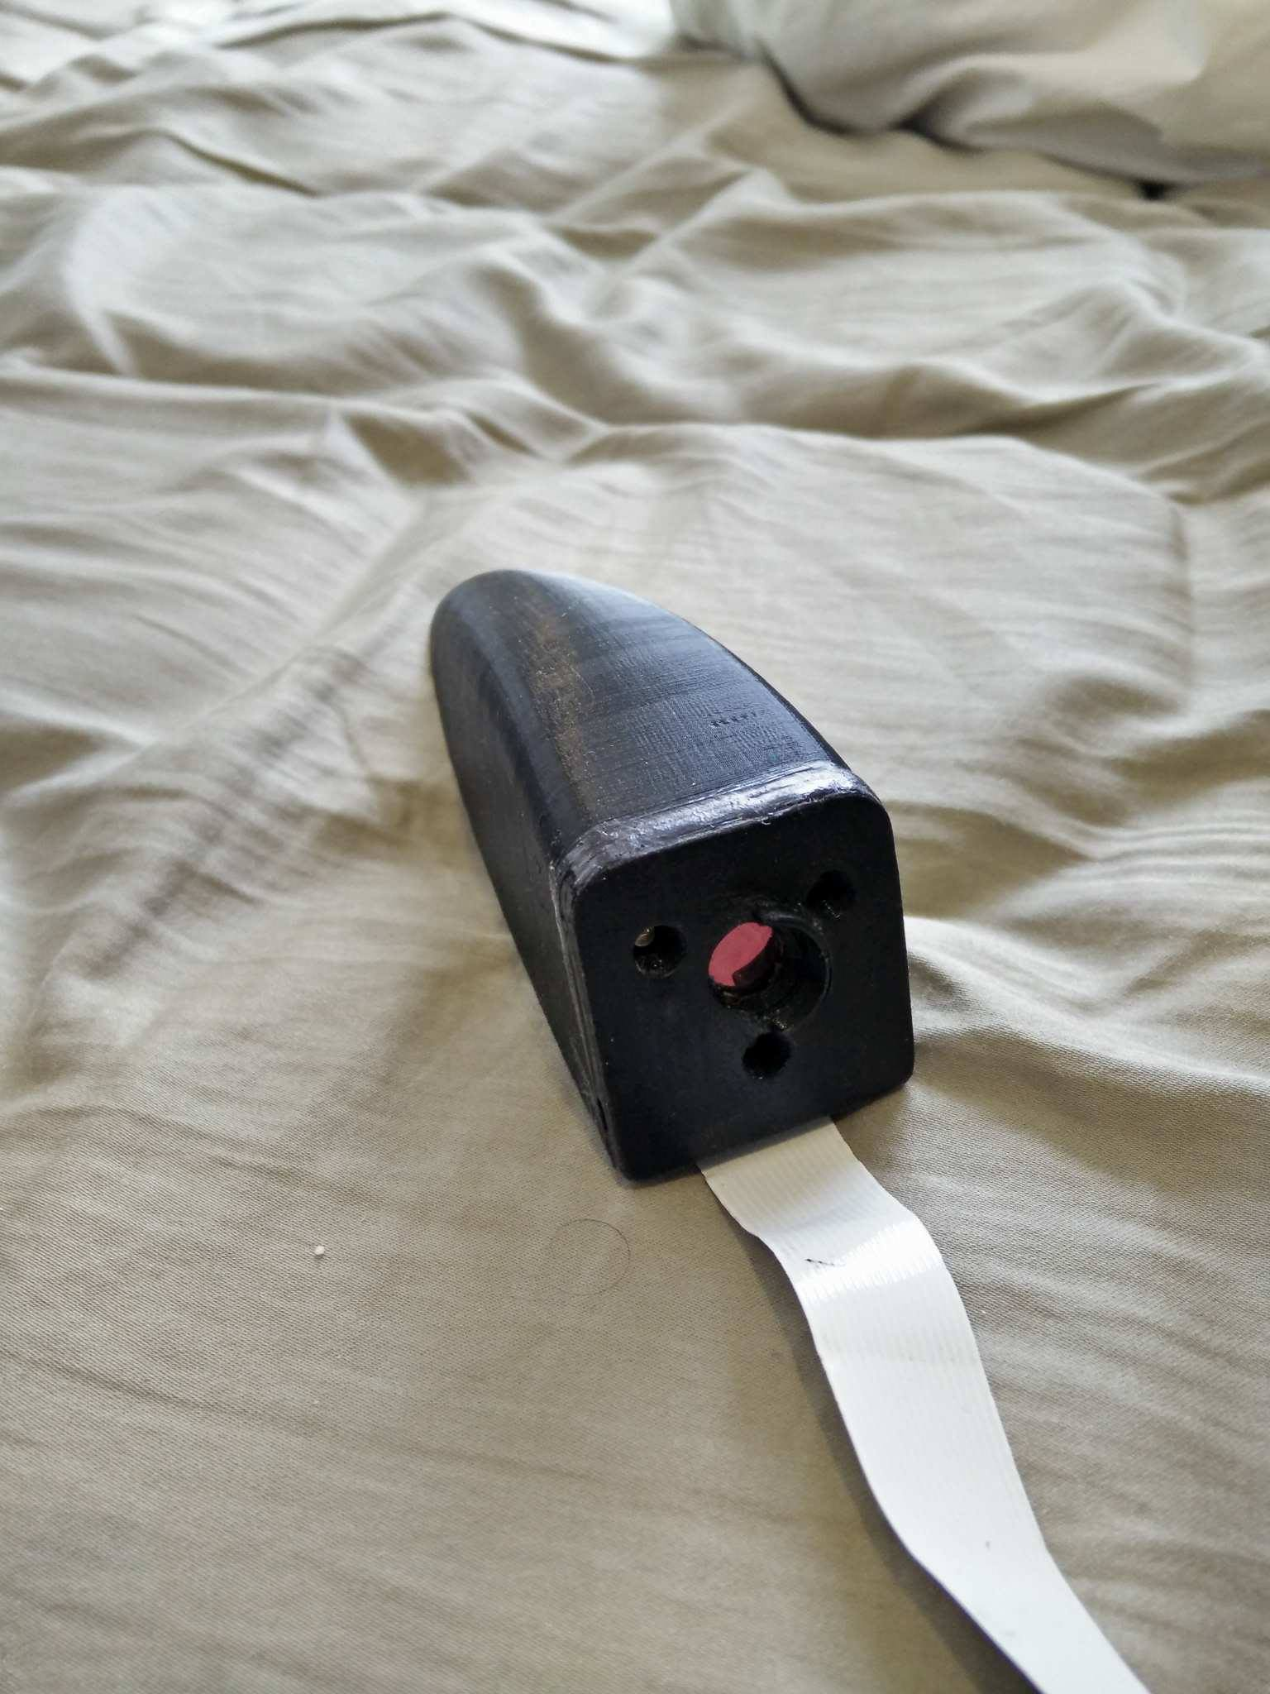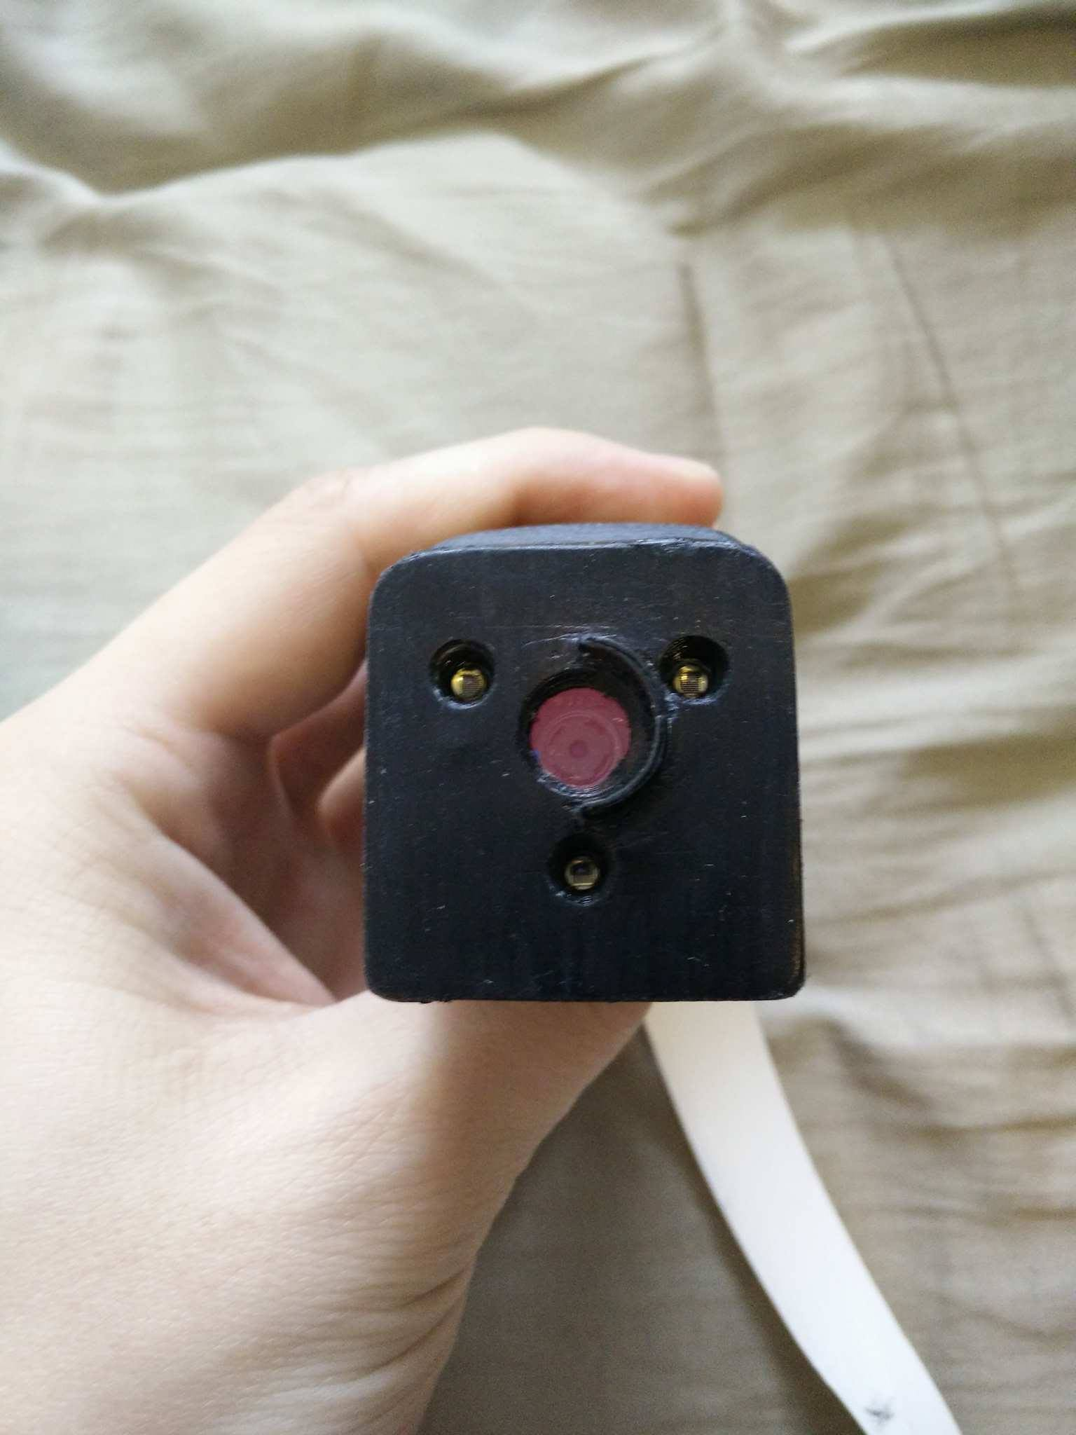

Appendix F : iteration #1 prototype 3d printed housing

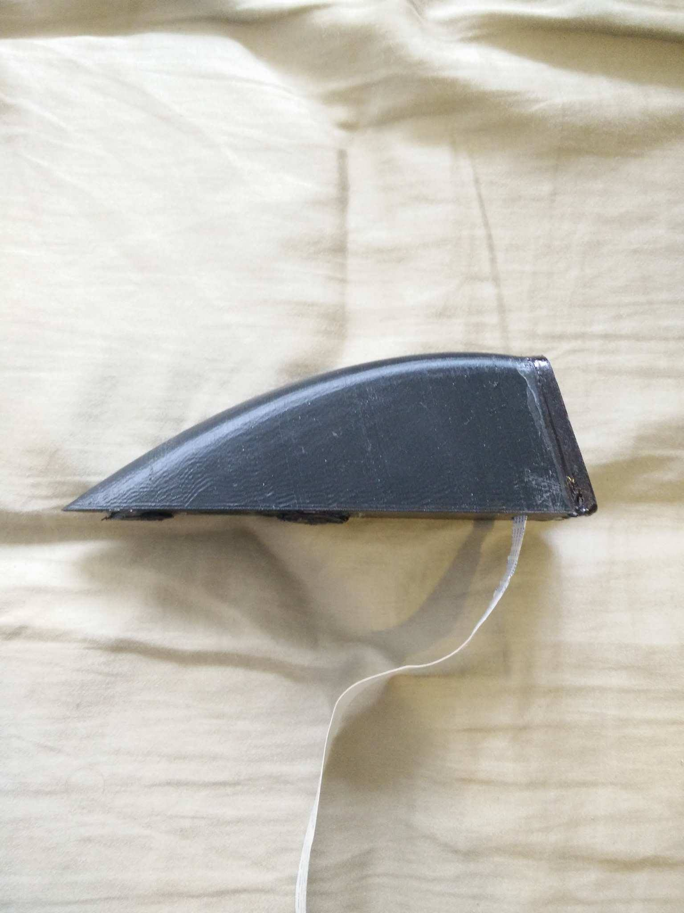

Appendix F : Iteration #1 side profile

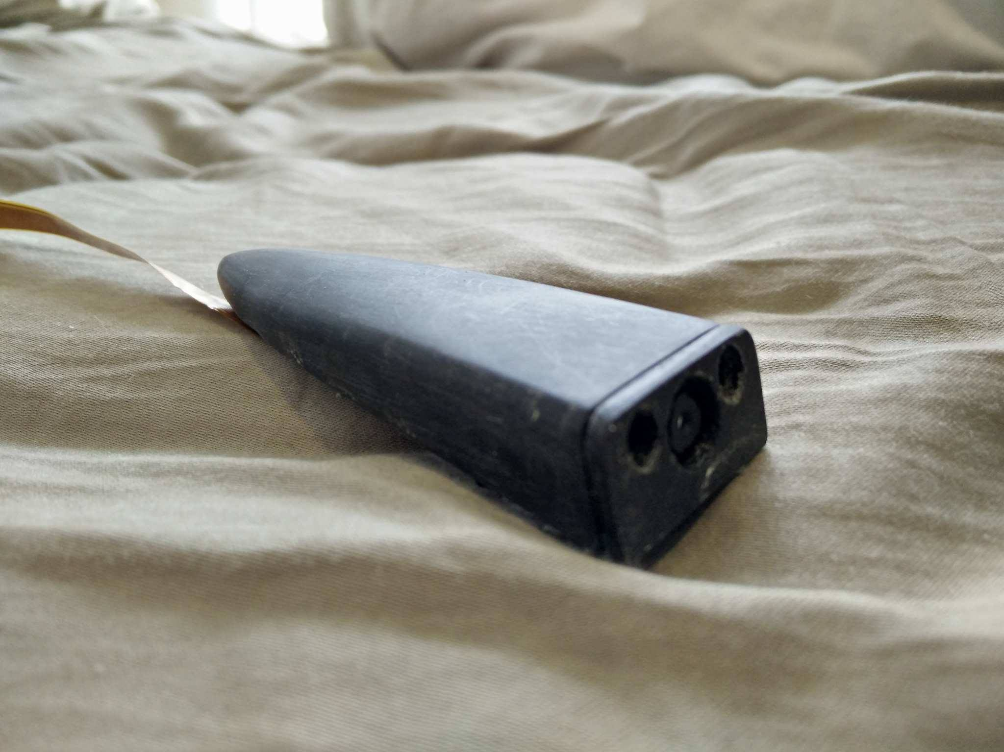

Appendix F : iteration #2 isometric profile

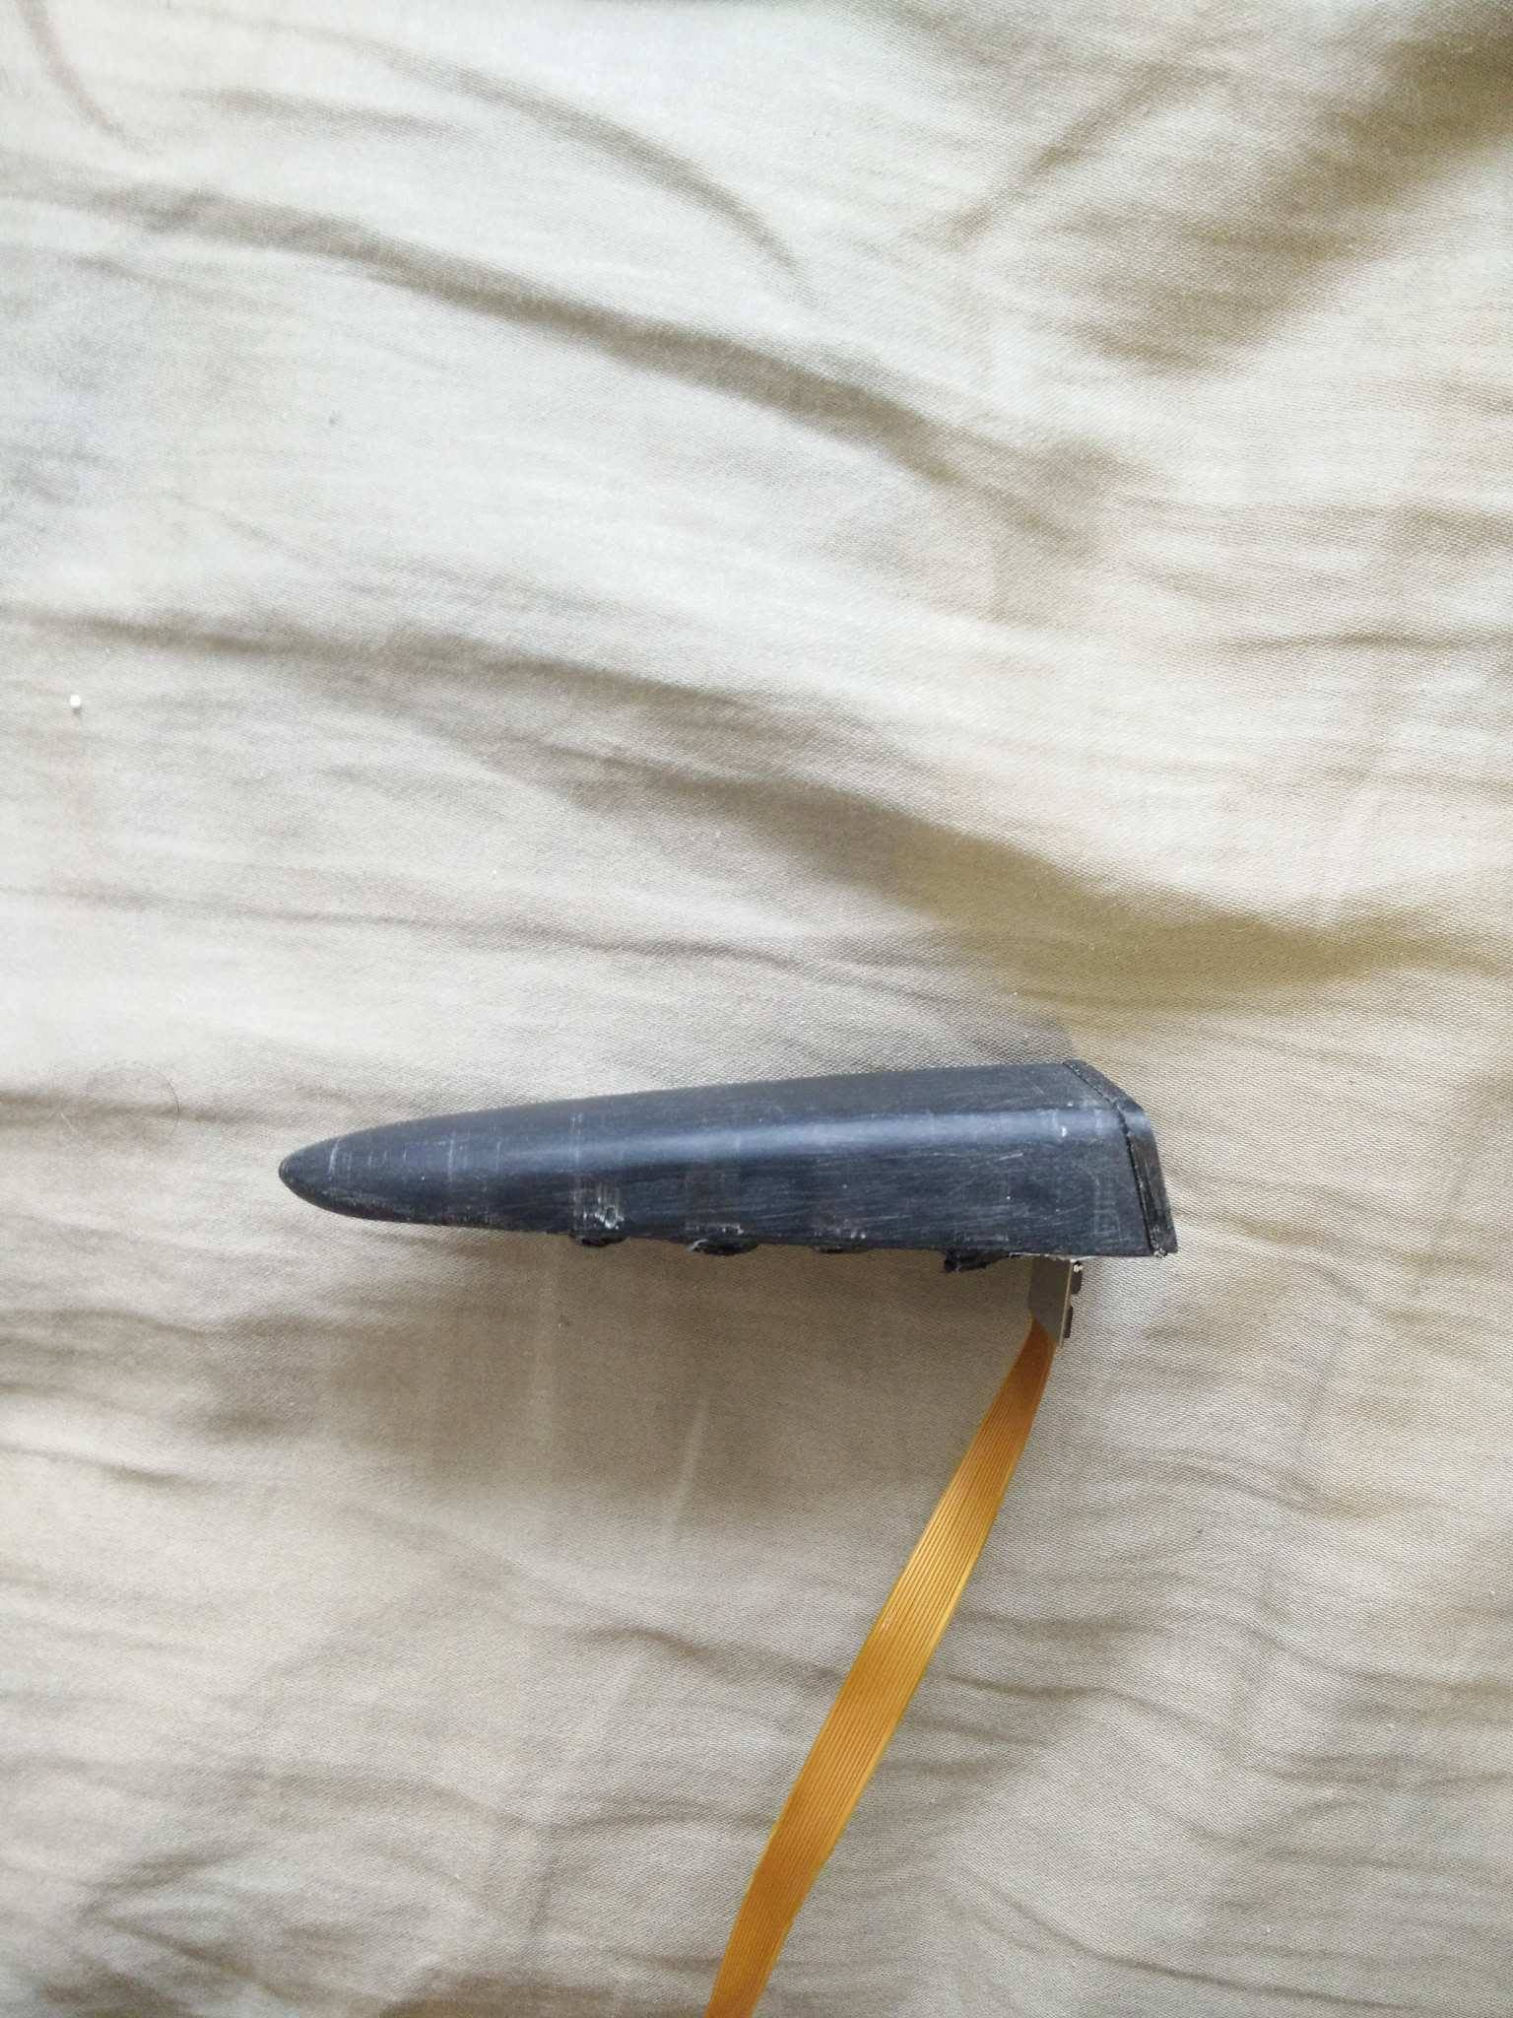

Appendix F : Iteration #2 side profile

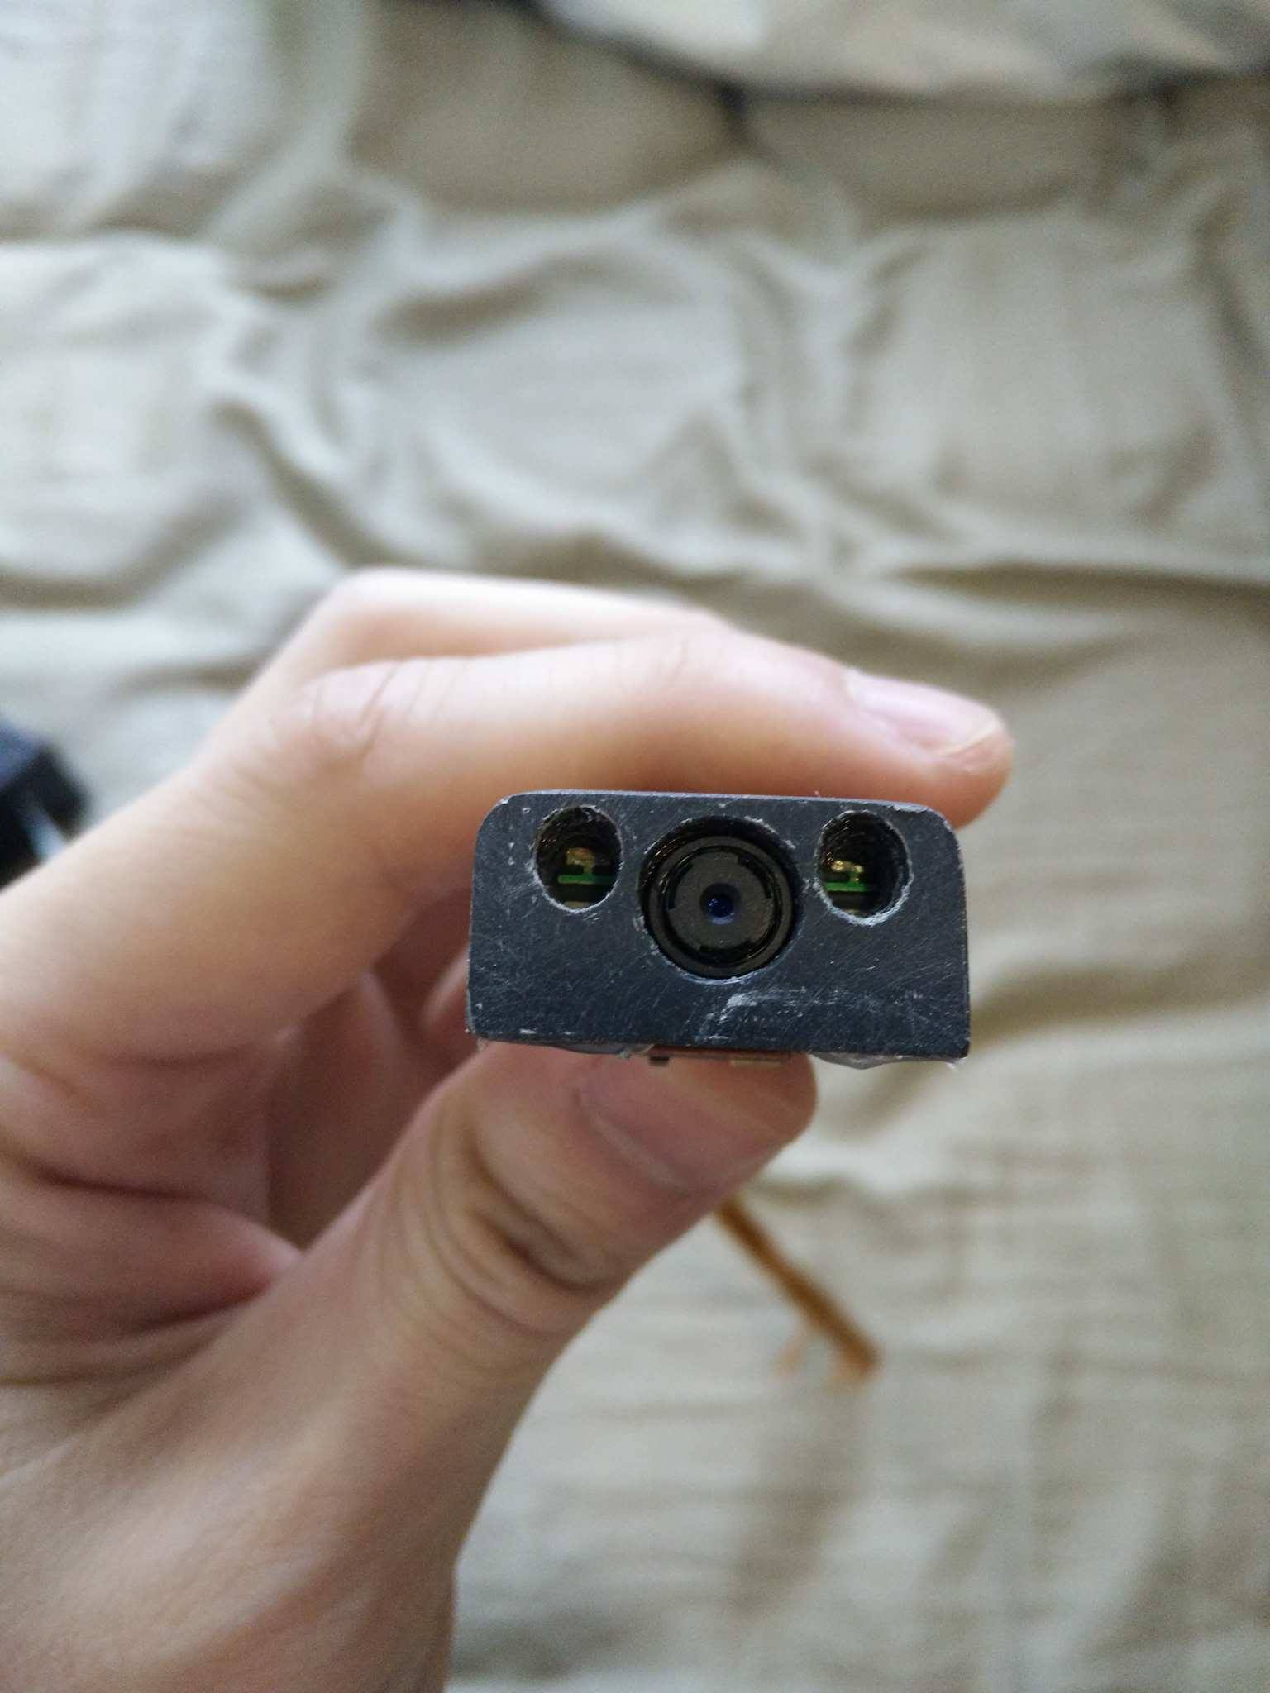

Appendix F : Iteration #2 cover front view

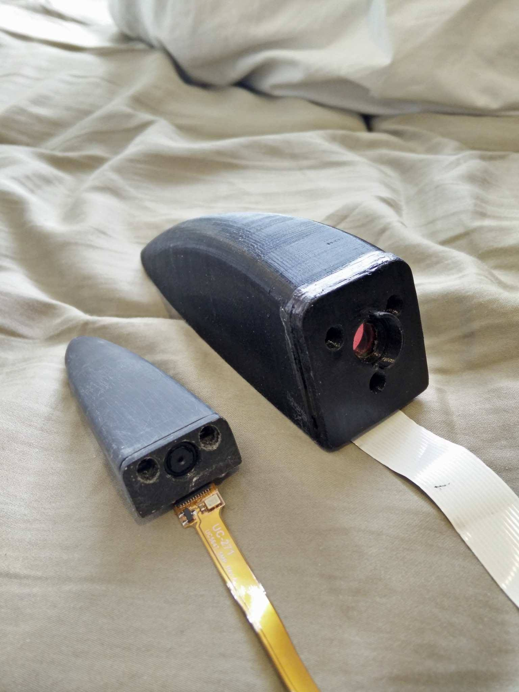

Appendix F : Iteration #1 (top right) vs Iteration #2 (bottom left) size comparison

# Appendix G: Project Management Data

|  |  |  |
| --- | --- | --- |
| Item | Planned Budget (CAD) | Expended Budget (CAD) |
| Camera | $ 150.00 | $ 270.62 |
| Housing | $ 70.00 | $ 28.58 |
| Heater | $ 50.00 | $ 36.39 |
| Electronic Components | $ 80.00 | $ 236.91 |
| PCB | $ 80.00 | $ 61.65 |
| Connectors | $ 30.00 | $ 5.50 |
| Sealing | $ 20.00 | $ 14.89 |
| Display | $ 120.00 | $ - |
| Processor | $ 100.00 | $ 73.34 |
| Symposium setup | $ 50.00 | $ 56.50 |
| Misc/Contingency | $ 150.00 | $ 127.74 |
| Total | $ 900.00 | $ 912.12 |

Appendix G 1: Project Budget

|  |  |  |
| --- | --- | --- |
| Member | Planned Hours | Actual Hours |
| Jame | 120 | 138 |
| Kelvin | 120 | 135 |
| Peter | 120 | 117 |
| Richard | 120 | 113 |
| Sean | 120 | 147 |
| Total | 600 | 650 |

Appendix G 2: Project Man-Hour Budget

|  |  |
| --- | --- |
| Deliverable | Due |
| Initial Design Review | Week 2 |
| Midterm Design Review | Week 6 |
| Redesign Freeze | Week 7 |
| Validation and Testing | Week 8 |
| Working Demonstration | Week 11 |
| Final Design Review | Week 11 |
| Symposium | Week 12 |

Appendix G 3: Project Deliverables

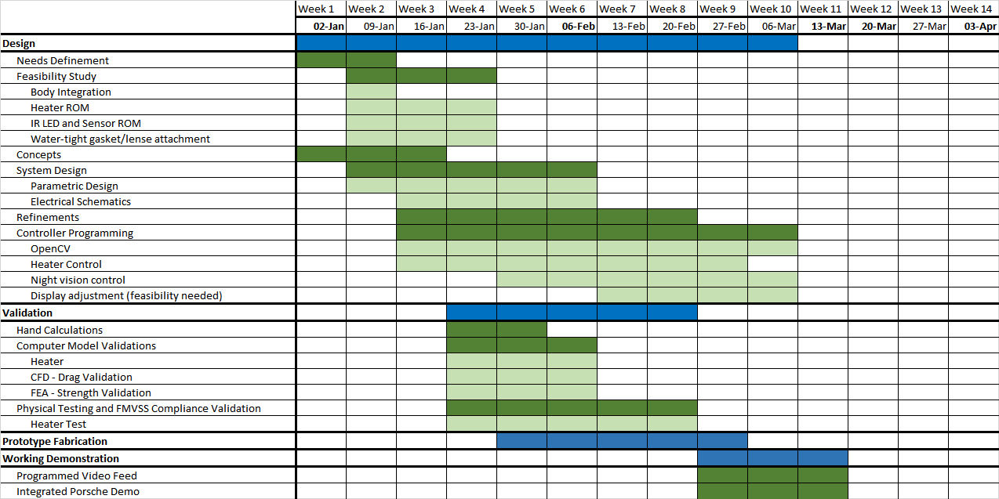

Appendix G 4: Project Schedule

1. Teamwork is also a learning outcome but not assessed as part of this assignment [↑](#footnote-ref-2)
2. Teamwork is also a learning outcome but not assessed as part of this assignment [↑](#footnote-ref-3)
3. Teamwork is also a learning outcome but not assessed as part of this assignment [↑](#footnote-ref-4)
4. Teamwork is also a learning outcome but not assessed as part of this assignment [↑](#footnote-ref-5)
5. Teamwork is also a learning outcome but not assessed as part of this assignment [↑](#footnote-ref-6)